UNIT I – Foundations of Deep Learning

What is Machine Learning and Deep Learning?
✅ Introduction
In today’s digital world, computers are no longer limited to performing fixed instructions written by programmers. Modern systems are designed to learn from data, identify patterns, and make intelligent decisions automatically.
This capability is achieved through Machine Learning (ML) and its advanced form known as Deep Learning (DL).
🧠 What is Machine Learning?
📌 Definition:
Machine Learning is a branch of Artificial Intelligence that enables a computer system to learn from data and improve its performance automatically without being explicitly programmed.
Instead of writing rules manually, we provide:
- Data
- A learning algorithm
- And the system discovers patterns
📊 Working Principle of Machine Learning:
- 1. Data is collected (images, numbers, text, etc.)
- 2. Features are extracted manually or automatically
- 3. A learning algorithm builds a model
- 4. The model makes predictions or decisions
- 5. Performance improves with more data
📌 Example:
If we want to detect spam emails:
- We give past labeled emails (spam / not spam)
- System learns word patterns
- Predicts new emails automatically
🤖 What is Deep Learning?
📌 Definition:
Deep Learning is a specialized subset of Machine Learning that uses multi-layered artificial neural networks to automatically learn complex patterns directly from raw data.
It mimics the human brain using:
- Neurons
- Layers
- Connections
Deep Learning removes the need for manual feature extraction.
🧩 Key Idea:
More layers = deeper understanding of data.
Example:
- First layer learns edges in images
- Next learns shapes
- Next learns objects
- Final predicts class
📈 Difference in Learning Approach
Aspect | Machine Learning | Deep Learning
Feature extraction | Mostly manual | Fully automatic
Data requirement | Small to medium | Very large
Accuracy | Good | Very high
Complexity | Lower | Very high
Computation | Moderate | Heavy (GPU based)
🧱 Diagram Required Here
Diagram Purpose: Basic working structure of Machine Learning vs Deep Learning
Graphviz DOT Code:
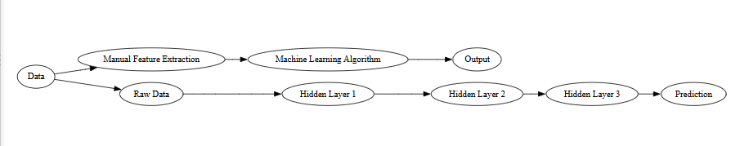
🌟 Advantages of Machine Learning
- Learns from experience
- Reduces human effort
- Works on large datasets
- Improves accuracy over time
🚀 Advantages of Deep Learning
- Handles unstructured data (images, audio, text)
- Automatically extracts features
- High accuracy in complex tasks
- Works well with big data
⚠ Limitations
Machine Learning:
- Needs feature engineering
- Limited for complex data
Deep Learning:
- Needs massive data
- Requires high computation
- Hard to interpret
📌 Real World Applications
Machine Learning:
- Recommendation systems
- Fraud detection
- Stock prediction
Deep Learning:
- Face recognition
- Speech recognition
- Autonomous vehicles
- Medical diagnosis
✅ Key Points to Remember (Exam Focus)
• Machine Learning learns from data using algorithms
• Deep Learning uses multi-layer neural networks
• ML needs feature extraction
• DL learns features automatically
• DL is powerful for large and complex data

History of Deep Learning
✅ Introduction
Deep Learning did not suddenly appear in recent years.
It evolved over more than 70 years through multiple research phases.
The development of deep learning can be divided into five major eras:
- 1. Early Neural Network Era (1940s–1960s)
- 2. First AI Winter (1970s)
- 3. Backpropagation Revival (1980s–1990s)
- 4. Second AI Winter (1990s–2000s)
- 5. Deep Learning Revolution (2006–Present)
🧠 1️⃣ Early Neural Network Era (1940s–1960s)
🔹 1943 – First Artificial Neuron Model
Warren McCulloch and Walter Pitts proposed the first mathematical model of a neuron.
They showed:
- A neuron can be represented using binary threshold logic.
- Neural activity can be modeled using mathematical equations.
This was the foundation of artificial neural networks.
🔹 1957 – Perceptron Model
Frank Rosenblatt introduced the Perceptron.
It was:
- A single-layer neural network
- Used for binary classification
It could solve:
- AND, OR problems
But could NOT solve:
- XOR problem (non-linearly separable)
📌 Why Perceptron Failed?
Because it was:
- Single layer
- Linear classifier
It could not learn complex patterns.
This limitation slowed research progress.
❄ 2️⃣ First AI Winter (1970s)
In 1969, Minsky and Papert published a book proving perceptron limitations.
As a result:
- Funding reduced
- Neural network research declined
- AI entered “AI Winter”
Deep learning research almost stopped.
🔁 3️⃣ Backpropagation Revival (1980s–1990s)
🔹 1986 – Backpropagation Algorithm
Geoffrey Hinton, Rumelhart, and Williams popularized Backpropagation.
Backpropagation allowed:
- Training multi-layer neural networks
- Updating weights using gradient descent
This solved:
- XOR problem
- Complex pattern learning
Neural networks became useful again.
🧮 Problem Still Exists
Even with backpropagation:
- Training was slow
- Data was limited
- Computers were weak
- Vanishing gradient problem occurred
So progress was limited.
❄ 4️⃣ Second AI Winter (1990s–Early 2000s)
During this period:
- Support Vector Machines (SVM)
- Decision Trees
- Statistical learning methods
became more popular.
Neural networks again lost popularity because:
- Training was computationally expensive
- Not enough labeled data
- GPUs were not available
🚀 5️⃣ Deep Learning Revolution (2006–Present)
This is the modern era.
🔹 2006 – Deep Belief Networks
Geoffrey Hinton introduced:
- Deep Belief Networks
- Layer-wise pretraining
This helped in solving:
- Vanishing gradient issue
The term “Deep Learning” became popular.
🔹 2012 – Breakthrough in ImageNet
AlexNet (developed by Hinton’s team) won ImageNet competition.
It used:
- Deep Convolutional Neural Networks (CNN)
- GPU acceleration
- ReLU activation
Error rate reduced drastically.
This event marked:
🎯 The official rise of Deep Learning
🔹 Reasons for Modern Success
Deep Learning succeeded due to:
- 1. Big Data availability
- 2. Powerful GPUs
- 3. Better activation functions (ReLU)
- 4. Improved optimization algorithms (Adam, RMSProp)
- 5. Large datasets like ImageNet
📊 Diagram Required Here
Diagram Purpose: Timeline of Deep Learning Evolution
Graphviz DOT Code:
📌 Major Contributors
• Warren McCulloch
• Walter Pitts
• Frank Rosenblatt
• Geoffrey Hinton
• Yann LeCun
• Yoshua Bengio
(These are known as “Godfathers of Deep Learning”)
📈 Summary of Evolution
Era | Status
1940s | Concept born
1950s | Perceptron invented
1970s | AI winter
1980s | Backpropagation revived
2006 | Deep models practical
2012+ | Industrial revolution in AI
🎯 Key Points for Exam
• Deep Learning evolved over 70+ years
• Perceptron limitations caused AI winter
• Backpropagation enabled multi-layer training
• GPUs + Big Data enabled modern success
• 2012 AlexNet was a turning point

Advantages and Challenges of Deep Learning
✅ Introduction
Deep Learning is a powerful branch of Machine Learning that uses multi-layer neural networks to automatically learn complex patterns from large volumes of data.
Unlike traditional algorithms that rely on manually designed features, deep learning systems learn representations directly from raw data, making them highly effective in real-world problems such as image recognition, speech processing, and language translation.
However, along with its tremendous success, deep learning also faces several technical and practical challenges.
🌟 ADVANTAGES OF DEEP LEARNING
1️⃣ Automatic Feature Extraction
In traditional machine learning:
👉 Humans manually select features (edges, shapes, patterns, etc.)
In deep learning:
👉 The network automatically learns useful features layer by layer.
Example:
In image recognition:
- First layer learns edges
- Next learns shapes
- Next learns objects
✅ Benefit:
• Reduces human effort
• Learns more accurate patterns
2️⃣ High Accuracy for Complex Problems
Deep learning models outperform classical algorithms in tasks involving:
• Images
• Audio
• Natural language
• Video
They can model non-linear and highly complex relationships.
Example:
Medical imaging systems detect cancer better than traditional ML.
3️⃣ Works Well with Big Data
Performance of deep learning improves as data increases.
More data → better representation → higher accuracy
This is opposite of many traditional algorithms that saturate quickly.
4️⃣ End-to-End Learning
Deep learning systems can take:
Raw Input → Final Output
in a single model.
No intermediate feature engineering required.
Example:
Speech → Text directly
Image → Object label directly
5️⃣ Adaptability Across Domains
Same architecture can be applied in:
• Healthcare
• Finance
• Robotics
• Self-driving cars
• Cybersecurity
Only data changes — model structure remains similar.

CHALLENGES OF DEEP LEARNING
1️⃣ Requires Huge Amount of Data
Deep networks contain millions of parameters.
To train properly they need:
✔ Very large labeled datasets
Without enough data:
• Overfitting occurs
• Poor generalization happens
Example:
Training face recognition requires thousands of images per person.
2️⃣ High Computational Cost
Deep learning requires:
• GPUs / TPUs
• High memory
• Long training time
Training large models can take:
⏳ Hours to weeks
This increases:
• Cost
• Energy consumption
3️⃣ Lack of Interpretability (Black Box Problem)
Deep models are hard to explain.
We know:
Input → Output
But we don’t clearly understand:
❓ Why a particular decision was made
This is dangerous in:
• Medical diagnosis
• Finance
• Law
Where explanations are necessary.
4️⃣ Overfitting Risk
Due to large number of parameters:
Model may memorize training data instead of learning patterns.
Results in:
• High training accuracy
• Low testing accuracy
Needs regularization, dropout, large datasets.
5️⃣ Difficult Hyperparameter Tuning
Deep learning performance depends heavily on:
• Learning rate
• Batch size
• Number of layers
• Neurons per layer
Wrong choice can lead to:
❌ Slow learning
❌ No convergence
❌ Poor accuracy
6️⃣ Requires Skilled Expertise
Designing deep networks requires knowledge of:
• Mathematics
• Optimization
• Neural architecture
• Data preprocessing
Not beginner-friendly.

📊 Comparative Summary (Exam Friendly)
Aspect | Advantage | Challenge
Feature learning | Automatic | Hard to control
Accuracy | Very high | Needs big data
Computation | Powerful models | Very expensive
Flexibility | Works everywhere | Complex design
Interpretation | Learns deeply | Black box
✅ Conclusion (Write this in exam)
Deep learning has revolutionized artificial intelligence by enabling machines to learn complex patterns directly from raw data with high accuracy. Its ability to perform automatic feature extraction and handle large-scale problems makes it superior to traditional machine learning methods.
However, its dependency on massive data, high computational resources, lack of transparency, and design complexity remain major challenges. Therefore, while deep learning is extremely powerful, careful implementation and resource planning are necessary for successful real-world deployment.

Learning Representations from Data
✅ Introduction
In traditional machine learning systems, humans manually design features from raw data.
For example:
• From images → edges, corners, shapes
• From text → word counts, grammar rules
• From audio → frequency patterns
This process is called feature engineering, and it requires strong domain knowledge.
Deep Learning removes this limitation by automatically learning useful representations directly from raw data.
This ability is known as:
👉 Learning Representations from Data
📌 What is a Representation?
A representation is a transformed form of raw data that makes patterns easier for a model to understand.
Example:
Raw image pixels → edges → shapes → objects
Each transformation extracts more meaningful information.
Simple Analogy:
Think of learning to read:
• First you recognize letters
• Then words
• Then sentences
• Then meaning
Similarly, deep learning builds understanding layer by layer.
🧠 How Deep Learning Learns Representations
Deep neural networks consist of multiple hidden layers.
Each layer learns a higher-level representation than the previous one.
Layer-wise Learning Process:
Layer | Learns
Input Layer | Raw data
Hidden Layer 1 | Simple patterns
Hidden Layer 2 | Intermediate patterns
Hidden Layer 3 | Complex patterns
Output Layer | Final prediction
Example (Image Recognition):
• Layer 1 → edges
• Layer 2 → corners
• Layer 3 → shapes
• Layer 4 → objects (face, car, animal)
This is called:
👉 Hierarchical Feature Learning
📈 Mathematical Intuition (simple)
Each layer performs:
Representation = Activation(Weights × Input + Bias)
Then passes output to next layer.
So each layer:
✔ Transforms data
✔ Makes it more meaningful
✔ Improves pattern detection

📊 Diagram Required Here
Diagram Purpose: Hierarchical representation learning in deep networks
Graphviz DOT Code:
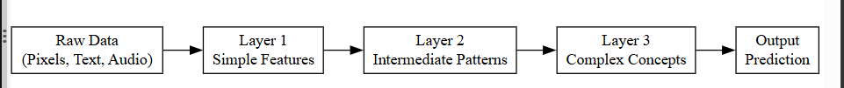

🎯 Why Learning Representations is Powerful
1️⃣ Eliminates Manual Feature Engineering
Traditional ML:
❌ Humans design features
Deep Learning:
✅ Model discovers features itself
This makes systems:
• Faster to develop
• More accurate
• Less dependent on experts
2️⃣ Handles Raw and Unstructured Data
Deep learning works directly on:
• Images
• Audio
• Videos
• Text
No need for heavy preprocessing.
3️⃣ Learns Complex Non-Linear Patterns
Representations become richer at deeper layers, allowing:
• Object detection
• Language translation
• Emotion recognition
Which are nearly impossible with hand-crafted features.
4️⃣ Improves Generalization
Good representations capture essential structure of data, leading to:
✔ Better performance on unseen data
✔ Robustness to noise
⚠ Limitations of Representation Learning
❗ Needs Large Data
To learn meaningful representations:
• Huge datasets are required
Otherwise:
• Model learns poor or misleading features
❗ Computationally Expensive
Multiple layers mean:
• Heavy matrix computations
• Long training times
❗ Hard to Interpret
We don’t clearly understand:
Why a particular neuron learned a specific pattern.

📌 Real-World Examples
Domain | Learned Representation
Image recognition | Edges → Objects
Speech recognition | Sound waves → Words
NLP | Characters → Meaning
Medical scans | Pixels → Tumors
✅ Conclusion (Perfect Exam Ending)
Learning representations from data is the fundamental strength of deep learning. Instead of relying on manually designed features, deep neural networks automatically discover hierarchical and meaningful patterns directly from raw input through multiple layers of transformation.
This enables deep learning systems to handle complex, high-dimensional, and unstructured data with superior accuracy. However, this power comes at the cost of large data requirements and high computational complexity.
🎯 Key Points to Remember
• Representation = meaningful transformation of raw data
• Deep networks learn features automatically
• Each layer learns higher-level concepts
• Enables handling of unstructured data
• Core reason for deep learning success

Understanding How Deep Learning Works
(Input Layer – Hidden Layers – Output Layer)
✅ Introduction
Deep Learning works using Artificial Neural Networks (ANNs) which are composed of:
- 1. Input Layer
- 2. One or more Hidden Layers
- 3. Output Layer
Information flows forward through these layers, where:
👉 Each layer transforms the data into a more meaningful form
👉 Final layer produces prediction or decision
This process is called Forward Propagation.
🧱 Overall Structure of a Deep Neural Network
A deep network is called “deep” because it has multiple hidden layers between input and output.
Each layer contains:
• Neurons (nodes)
• Weights (connections)
• Biases
• Activation functions
📥 1️⃣ Input Layer
📌 Role of Input Layer
The input layer:
• Receives raw data
• Passes it to the first hidden layer
• Performs no computation (only forwarding values)
Example:
For an image:
- Each pixel value becomes one input neuron
For student marks:
- Each subject mark becomes one input neuron
Mathematically:
If input vector is:
X = [x₁, x₂, x₃, …, xₙ]
It is sent to hidden layer neurons.
🧠 2️⃣ Hidden Layers (Core of Learning)
📌 Purpose of Hidden Layers
Hidden layers perform:
✔ Feature extraction
✔ Pattern learning
✔ Non-linear transformation
This is where actual intelligence happens.
🔁 Working of a Single Neuron
Each neuron computes:
Weighted sum + Bias → Activation
Formula:
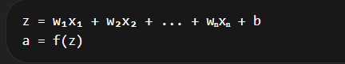
Where:
• w = weights
• b = bias
• f = activation function (ReLU, sigmoid, tanh, etc.)
📈 Why Multiple Hidden Layers?
Each additional layer:
• Learns more complex features
• Builds hierarchical understanding
Example:
Layer 1 → simple patterns
Layer 2 → combinations
Layer 3 → high-level concepts
🎯 Effect:
Shallow network → simple problems
Deep network → complex real-world problems
📤 3️⃣ Output Layer
📌 Role of Output Layer
The output layer:
• Produces final result
• Converts learned representation into prediction

Common cases:
Task | Output
Binary classification | 0 or 1
Multi-class classification | probabilities
Regression | continuous value
Example:
Email spam detection → Spam / Not Spam
Digit recognition → 0 to 9
🔄 Complete Working Flow (Step-by-Step)
✅ Step 1: Input enters network
Raw data is fed into input layer.
✅ Step 2: Hidden layers transform data
Each layer:
• Multiplies by weights
• Adds bias
• Applies activation function
Creating learned representations.
✅ Step 3: Output produced
Final layer gives:
• Class label
• Probability
• Numeric value
✅ Step 4: Error calculated (later in training)
Difference between prediction and actual value is computed (loss).

📊 Diagram Required Here
Diagram Purpose: Flow of data in Deep Neural Network
Graphviz DOT Code:

📈 Why This Architecture Works So Well
✅ Non-Linearity
Activation functions allow network to learn:
• Curves
• Complex relationships
• Real-world patterns
Without them, network becomes just linear math.
✅ Hierarchical Learning
Each layer builds on previous one:
Simple → Complex → Intelligent

✅ Scalability
More layers → More power → Better performance on complex tasks
⚠ Limitations of This Structure
❗ Needs large data
❗ High computation
❗ Risk of vanishing gradients
❗ Overfitting if too deep
✅ Conclusion (Perfect exam ending)
Deep learning works by passing input data through multiple hidden layers where weighted computations and activation functions progressively transform raw information into meaningful representations. The input layer receives data, hidden layers perform feature learning and pattern extraction, and the output layer generates final predictions.
This layered hierarchical structure enables deep neural networks to solve complex real-world problems with high accuracy, making it the core mechanism behind modern artificial intelligence systems.
🎯 Key Points to Remember
• Input layer receives raw data
• Hidden layers perform learning
• Weights + bias + activation transform data
• Output layer gives prediction
• Multiple layers enable complex pattern learning

📘 Common Architectural Principles of Deep Networks
✅ Introduction
Deep neural networks are not built randomly.
They follow specific architectural principles that help:
• Learn complex patterns efficiently
• Train faster
• Avoid instability
• Improve generalization
These principles guide how layers, neurons, connections, and learning flow are organized.
Without these principles, deep networks would:
❌ Train slowly
❌ Become unstable
❌ Fail to generalize
🧱 Major Architectural Principles of Deep Networks
1️⃣ Layered Hierarchical Structure
📌 Concept:
Deep networks are organized in multiple layers, where each layer learns increasingly abstract representations.
Flow:
Raw data → simple features → complex patterns → final decision
Why important?
• Mimics human brain learning
• Enables representation learning
• Handles complex data
Example:
Image:
Pixels → edges → shapes → objects
2️⃣ Parameter Sharing
📌 Concept:
Same weights are reused across different parts of input.
Instead of learning separate weights for each input location, the network:
👉 Uses common parameters
Benefits:
✔ Reduces memory
✔ Speeds training
✔ Improves generalization
Common in:
Convolutional Neural Networks (CNNs)
Example:
One filter detects edges across entire image.
3️⃣ Local Connectivity
📌 Concept:
Neurons connect only to a small region of previous layer instead of full connection.
Why?
• Real-world data has local patterns
• Reduces parameters
• Focuses on meaningful features
Example:
In images:
Nearby pixels form patterns — not distant ones.
4️⃣ Non-Linearity Through Activation Functions
📌 Concept:
Each layer applies non-linear activation functions such as:
• ReLU
• Sigmoid
• Tanh
Why needed?
Without non-linearity:
Network becomes a simple linear model — no matter how many layers.
With non-linearity:
✔ Learns curves
✔ Learns complex relationships
✔ Models real-world data
5️⃣ Depth for Feature Composition
📌 Concept:
Deeper networks combine simpler features to form complex ones.
This is called:
👉 Feature composition
Example:
Edges → shapes → face → person identity
Advantage:
More depth = richer understanding
6️⃣ Regularization for Stability
📌 Techniques used in architecture:
• Dropout
• Weight decay
• Batch normalization
Purpose:
✔ Prevent overfitting
✔ Improve convergence
✔ Stabilize learning
7️⃣ Modular Design
📌 Concept:
Networks are built using reusable blocks.
Example blocks:
• Convolution + ReLU + Pooling
• Dense + BatchNorm + Activation
Benefits:
• Easy scaling
• Easy debugging
• Better design control
📊 Diagram Required Here
Diagram Purpose: Architectural flow showing layered hierarchical learning
Graphviz DOT Code:

📈 How These Principles Help Deep Learning
Principle | Effect
Hierarchy | Better understanding
Sharing | Fewer parameters
Locality | Efficient learning
Non-linearity | Complex pattern modeling
Depth | High abstraction
Regularization | Stable training
Modularity | Scalable design
⚠ If These Are Ignored:
❌ Overfitting increases
❌ Training becomes unstable
❌ Network becomes inefficient
❌ Accuracy drops
✅ Conclusion (Write exactly in exam)
Common architectural principles such as hierarchical layered structure, parameter sharing, local connectivity, non-linear activation, feature composition, regularization, and modular design form the backbone of deep neural networks. These principles enable efficient learning, stability, scalability, and high performance in complex real-world problems. By following these design concepts, deep learning models can automatically learn rich representations from raw data and achieve superior accuracy.
🎯 Key Points to Remember
• Deep networks are hierarchical
• Features learned layer by layer
• Weights can be shared
• Non-linearity is essential
• Regularization prevents overfitting
• Modular blocks improve design

Applications of Deep Learning
📌 PYQ: Q1 (c) – State any five applications of Deep Learning
✅ Introduction
Deep Learning has significantly transformed modern artificial intelligence by enabling machines to automatically learn complex patterns from large volumes of data. Due to its ability to process unstructured data such as images, audio, text, and video, deep learning has been widely adopted across various industries.
Some of the major applications of deep learning are explained below.
1️⃣ Computer Vision

📌 Explanation:
Deep learning models, especially Convolutional Neural Networks (CNNs), are widely used in image and video processing tasks.
They automatically learn visual features such as:
- Edges
- Shapes
- Objects
- Faces
🔹 Applications:
• Face recognition systems
• Object detection
• Image classification
• Medical image analysis
• Self-driving car vision systems
Example:
Autonomous vehicles use deep learning to detect:
- Traffic lights
- Pedestrians
- Road signs
2️⃣ Natural Language Processing (NLP)
📌 Explanation:
Deep learning models process and understand human language using architectures such as RNNs, LSTMs, and Transformers.
They learn:
- Word meanings
- Sentence structure
- Context relationships
🔹 Applications:
• Machine translation
• Chatbots
• Sentiment analysis
• Text summarization
• Spam detection
Example:
Google Translate uses deep neural networks for language translation.
3️⃣ Speech Recognition
📌 Explanation:
Deep learning models convert audio signals into text by learning patterns in sound waves.
They analyze:
- Frequency
- Pitch
- Tone
- Phonemes
🔹 Applications:
• Virtual assistants
• Voice typing
• Smart home devices
• Call center automation
Example:
Voice assistants convert spoken commands into actions using deep networks.
4️⃣ Healthcare and Medical Diagnosis
📌 Explanation:
Deep learning helps in analyzing medical data such as:
• X-rays
• MRI scans
• CT scans
• Genomic data
It can detect patterns that are difficult for humans to observe.
🔹 Applications:
• Cancer detection
• Tumor classification
• Disease prediction
• Drug discovery
Example:
Deep learning models can identify early-stage tumors from medical images with high accuracy.
5️⃣ Recommendation Systems
📌 Explanation:
Deep learning models analyze user behavior patterns and preferences.
They learn relationships between:
- Users
- Products
- Content
🔹 Applications:
• Movie recommendations
• Product suggestions
• Music streaming suggestions
• Personalized advertisements
Example:
Streaming platforms recommend movies based on viewing history.
6️⃣ Autonomous Systems
📌 Explanation:
Deep learning enables machines to make intelligent decisions in real time.
🔹 Applications:
• Self-driving cars
• Robotics
• Drone navigation
These systems combine:
- Computer vision
- Decision-making models
- Reinforcement learning
7️⃣ Fraud Detection & Cybersecurity
📌 Explanation:
Deep learning detects unusual transaction patterns and network intrusions.
It identifies:
- Anomalies
- Suspicious activities
- Fraudulent transactions

📊 Diagram Required Here
Diagram Purpose: Major Application Domains of Deep Learning
Graphviz DOT Code:
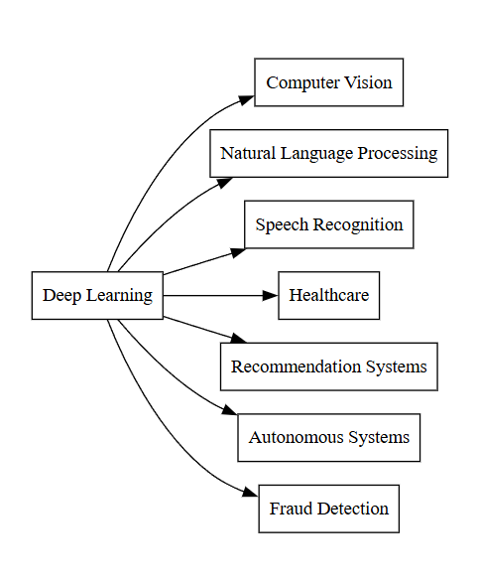

📈 Why Deep Learning is Widely Used
• Handles large-scale data
• Learns automatically
• Works with unstructured data
• Provides high accuracy
• Adapts to multiple industries
✅ Conclusion (Perfect Ending)
Deep learning has revolutionized various domains by enabling systems to automatically learn complex representations from large-scale structured and unstructured data. Its applications span across computer vision, natural language processing, speech recognition, healthcare, recommendation systems, autonomous vehicles, and cybersecurity. Due to its high accuracy and scalability, deep learning continues to expand into new industrial and research areas.
🎯 Key Points to Write in Exam
• Mention at least five applications
• Explain each briefly
• Give one real-world example
• Maintain structured answer
• Add conclusion

Hyperparameters in Deep Learning
📌 PYQ: What are hyperparameters? Explain any two in brief
✅ Introduction
In deep learning, training a neural network involves two types of parameters:
🔹 Model Parameters:
These are learned automatically from data.
Example:
• Weights
• Biases
🔹 Hyperparameters:
These are set by the user before training and control:
• Learning process
• Network structure
• Speed and quality of convergence
👉 Hyperparameters are not learned — they are tuned.

📌 Definition:
Hyperparameters are external configuration variables that govern the behavior of the learning algorithm and network architecture, determining how effectively a deep learning model is trained.

🎯 Why Hyperparameters Are Important
Wrong hyperparameters can lead to:
❌ Slow training
❌ No convergence
❌ Overfitting
❌ Poor accuracy
Correct tuning leads to:
✅ Fast convergence
✅ Stable learning
✅ High performance

📊 Major Hyperparameters (As per Syllabus)

1️⃣ Learning Rate (η)

📌 Meaning:
Learning rate determines:
👉 How much the weights are updated during each training step.

Mathematically:
New Weight = Old Weight − η × Gradient

📈 Effect:
Learning Rate | Result
Too small | Training very slow
Too large | Model diverges
Optimal | Fast and stable learning

✅ Importance:
Controls speed and stability of training.

2️⃣ Regularization

📌 Meaning:
Regularization is a technique used to prevent overfitting by adding a penalty to large weights.

Common Types:
• L1 Regularization
• L2 Regularization (most common)
• Dropout

📈 Effect:
Encourages simpler models that generalize better.

Example:
Large weights are penalized → model avoids memorizing data.

3️⃣ Momentum

📌 Meaning:
Momentum accelerates gradient descent by:
👉 Using past gradients to smooth current updates.

Working:
Instead of only current gradient, it combines:
Current + previous movement

Benefit:
• Faster convergence
• Reduces oscillation
• Helps escape local minima

4️⃣ Sparsity

📌 Meaning:
Sparsity encourages many neuron activations to be:
👉 Zero or near zero
This means:
Only important neurons activate.

Benefits:
• Efficient representation
• Reduced overfitting
• Better generalization

Example:
Brain-like behavior — only some neurons fire at a time.

5️⃣ Hidden Units (Neurons per Layer)

📌 Meaning:
Number of neurons in each hidden layer.

Effect:
Too Few | Too Many
Underfitting | Overfitting
Poor learning | Heavy computation

Proper choice:
Balances complexity and performance.

📊 Diagram Required Here
Diagram Purpose: Influence of hyperparameters on training process
Graphviz DOT Code:
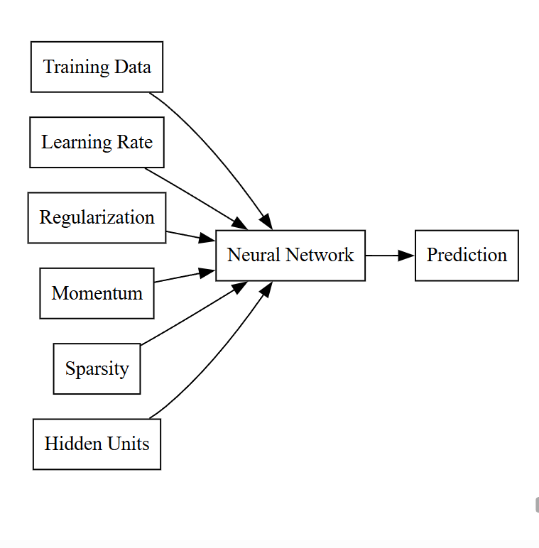

✅ Conclusion (Exam Perfect)
Hyperparameters play a crucial role in controlling the training behavior and performance of deep learning models. Parameters such as learning rate determine convergence speed, regularization prevents overfitting, momentum improves optimization efficiency, sparsity enhances representation efficiency, and the number of hidden units controls model complexity. Proper tuning of hyperparameters is essential for achieving stable training and high predictive accuracy.

🎯 Key Points for PYQ
• Hyperparameters are user-defined
• Control training and architecture
• Learning rate controls updates
• Regularization prevents overfitting
• Momentum speeds convergence
• Sparsity improves efficiency
• Hidden units affect complexity

Cost Functions in Deep Learning

✅ Introduction
In deep learning, a neural network makes predictions.
But how does it know whether its prediction is good or bad?
This is measured using a Cost Function.
📌 Definition:
A cost function is a mathematical function that measures the difference between the predicted output of a model and the actual (true) output.
It tells:
👉 How wrong the model is
👉 How much to adjust weights during training
The main goal of training is:
🎯 Minimize the cost function

🧠 Why Cost Functions Are Important
Without a cost function:
❌ No measure of error
❌ No learning direction
❌ No weight update
❌ No improvement
Cost function provides:
✔ Learning signal
✔ Optimization target
✔ Performance feedback

🔁 Role of Cost Function in Training Process
- 1. Model predicts output
- 2. Cost function calculates error
- 3. Backpropagation computes gradients
- 4. Optimizer updates weights
- 5. Error reduces gradually
This repeats until minimum error is achieved.

📊 Diagram Required Here
Diagram Purpose: Role of cost function in neural network training
Graphviz DOT Code:
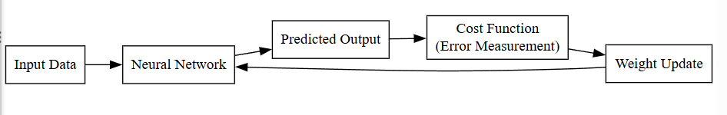

📈 General Mathematical Form
For one data point:
Cost = f(Actual Output, Predicted Output)

For entire dataset:
Total Cost = Average of all individual losses

📚 Types of Cost Functions (Conceptual Level)
Cost functions depend on problem type:

🔹 1. For Regression Problems (predict numbers)
Example: house price prediction
Common cost:
Mean Squared Error (MSE)
MSE = (1/n) Σ (Actual − Predicted)²

Meaning:
• Measures squared difference
• Penalizes large errors strongly
Advantages:
✔ Smooth
✔ Easy to optimize
✔ Widely used

🔹 2. For Classification Problems (predict classes)
Example: spam or not spam
Common cost:
Cross-Entropy Loss
It compares:
• True class probability
• Predicted probability
Meaning:
• High penalty for confident wrong predictions
• Encourages correct classification

🔹 3. For Binary Classification
Example: yes/no decision
Uses:
Binary Cross Entropy

🔹 4. For Multi-class Classification
Example: digit recognition (0–9)
Uses:
Categorical Cross Entropy

⚙️ Properties of a Good Cost Function
A good cost function should:
✔ Be differentiable
✔ Provide meaningful gradient
✔ Penalize wrong predictions strongly
✔ Be stable during training

📉 What Happens If Cost Function is Poorly Chosen?
❌ Slow convergence
❌ Wrong learning direction
❌ Model instability
❌ Poor accuracy

📌 Real Example
Suppose:
Actual output = 5
Predicted output = 3
Error = 2
MSE = (5 − 3)² = 4
Larger mistake → larger penalty
So model learns to reduce it.

✅ Conclusion (Write in exam)
A cost function is a fundamental component of deep learning that quantifies the error between predicted outputs and actual targets. It guides the learning process by providing feedback used in backpropagation to update network weights. Different cost functions are selected based on problem type such as regression or classification. Proper selection of cost function ensures stable training, faster convergence, and high model accuracy.

🎯 Key Points to Remember
• Measures prediction error
• Drives learning process
• Must be minimized
• Different for regression & classification
• Guides backpropagation

Error Backpropagation Algorithm

✅ Introduction
Backpropagation is the fundamental algorithm used to train multi-layer neural networks.
📌 Definition:
Backpropagation is a supervised learning algorithm used to minimize the cost function by computing gradients of the loss with respect to network weights using the chain rule of calculus.
It allows:
- Efficient training of deep networks
- Updating weights layer by layer
- Minimizing prediction error

🧠 Why Backpropagation is Needed
A neural network makes predictions.
But to improve predictions, we must:
- 1. Measure error (using cost function)
- 2. Find how much each weight contributed to error
- 3. Adjust weights accordingly
Backpropagation does exactly this.

🔁 Two Main Phases of Backpropagation
1️⃣ Forward Propagation
2️⃣ Backward Propagation

🧮 Step 1: Forward Propagation
Input passes through network:
For each neuron:
Where:
- = weight
- = input
- = bias
- = activation function
Final output is produced.
Then cost is computed:
Where:
- = actual output
- = predicted output

🔄 Step 2: Backward Propagation
Now we calculate:
👉 How much each weight affects the cost
This is done using:
🔹 Chain Rule of Calculus
If:
Then:
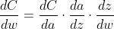
This tells how much change in weight affects total error.

📉 Weight Update Rule
After computing gradient:
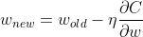
Where:
- = learning rate
- = gradient
This reduces cost step by step.

📊 Diagram Required Here
Diagram Purpose: Forward and Backward Flow in Backpropagation
Graphviz DOT Code:
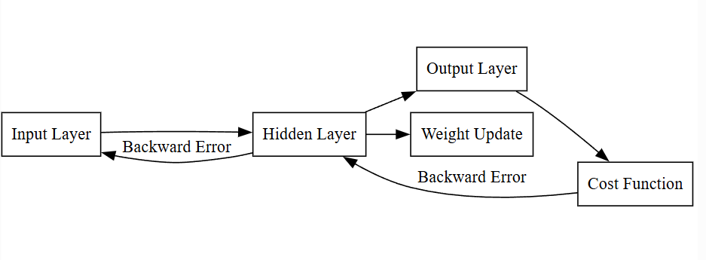

🧾 Complete Backpropagation Algorithm (Step-by-Step)
- 1. Initialize weights randomly
- 2. Perform forward propagation
- 3. Compute cost
- 4. Compute output layer error
- 5. Propagate error backward to hidden layers
- 6. Compute gradients
- 7. Update weights
- 8. Repeat until cost is minimized

📈 Why Backpropagation Works
✔ Efficient gradient computation
✔ Works for multi-layer networks
✔ Uses calculus for optimization
✔ Enables deep learning revolution
Without backpropagation:
❌ Deep networks cannot be trained
❌ Only shallow models would work

⚠ Limitations
- Can suffer from vanishing gradients
- Requires differentiable activation functions
- Computationally intensive

🧠 Intuitive Understanding
Think of it like:
Teacher checks exam paper →
Finds mistake →
Tells student exactly where mistake happened →
Student corrects it.
Backpropagation tells each weight:
“You contributed this much error — correct yourself.”

✅ Conclusion (Exam Perfect Ending)
Backpropagation is a supervised learning algorithm that enables efficient training of multi-layer neural networks by computing gradients of the cost function using the chain rule of calculus. It consists of forward propagation to compute predictions and backward propagation to calculate gradients and update weights. This algorithm forms the backbone of modern deep learning systems and allows deep neural networks to learn complex patterns from data.

🎯 Key Points for 5 Marks
- Uses gradient descent
- Based on chain rule
- Has forward and backward pass
- Updates weights iteratively
- Minimizes cost function

Gradient-Based Learning & Implementing Gradient Descent

✅ Introduction
Deep learning models learn by minimizing the cost function.
To minimize this error efficiently, we use a family of methods called:
👉 Gradient-Based Learning
The most fundamental algorithm in this family is:
🎯 Gradient Descent

📌 Definition:
Gradient-based learning is an optimization approach where model parameters (weights and biases) are updated in the direction opposite to the gradient of the cost function in order to reduce error.

🧠 What is a Gradient?
A gradient is the rate of change of the cost function with respect to model parameters.
Mathematically:
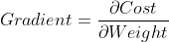
It tells:
• How much error increases or decreases
• Which direction gives minimum error

📈 Intuition:
Imagine standing on a hill:
• Gradient points uphill
• Going opposite direction moves downhill
Goal of training = reach the lowest valley (minimum error)

🔁 Gradient-Based Learning Process
- 1. Compute prediction
- 2. Calculate cost
- 3. Compute gradient using backpropagation
- 4. Update parameters
- 5. Repeat until error is minimized

📉 Gradient Descent Algorithm

📌 Basic Idea:
Update weights gradually to minimize cost.

Mathematical Update Rule:

Where:
• = weight
• = learning rate
• = gradient
• = cost function

Meaning:
Move weights slightly in the direction that reduces error.

📊 Diagram Required Here
Diagram Purpose: Gradient descent minimizing cost function
Graphviz DOT Code:
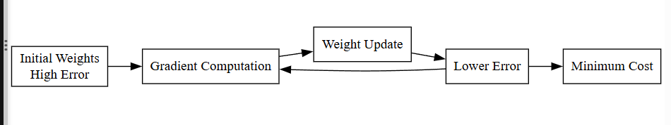

🧪 Types of Gradient Descent (Implementation Perspective)

1️⃣ Batch Gradient Descent
Uses:
✔ Entire training dataset for each update
Pros:
• Stable convergence
• Accurate gradient
Cons:
• Very slow
• High memory usage

2️⃣ Stochastic Gradient Descent (SGD)
Uses:
✔ One training example at a time
Pros:
• Fast updates
• Escapes local minima
Cons:
• Noisy learning
• Fluctuating convergence

3️⃣ Mini-Batch Gradient Descent
Uses:
✔ Small batch of samples
Pros:
• Balanced speed and stability
• Most commonly used

⚙️ Step-by-Step Implementation of Gradient Descent

Step 1: Initialize weights randomly

Step 2: Forward propagate input

Step 3: Compute cost

Step 4: Compute gradients via backpropagation

Step 5: Update weights

Step 6: Repeat for many epochs
Until cost becomes minimum.

📈 Why Gradient-Based Learning Works Well
✔ Efficient for large models
✔ Works with millions of parameters
✔ Scales to big data
✔ Mathematically sound

⚠ Challenges

❗ Sensitive to learning rate
❗ May get stuck in local minima
❗ Can be slow for deep networks
❗ Vanishing gradient problem
(Which leads to next topic!)

✅ Conclusion (Exam Perfect)
Gradient-based learning is the fundamental optimization approach used to train deep neural networks by minimizing the cost function through iterative parameter updates. Gradient descent updates weights in the opposite direction of the error gradient using a learning rate to control step size. Variants such as batch, stochastic, and mini-batch gradient descent improve efficiency and convergence. This method, combined with backpropagation, forms the core learning mechanism of deep learning systems.

🎯 Key Points to Remember
• Uses gradient of cost function
• Updates weights iteratively
• Moves toward minimum error
• Learning rate controls step size
• Exists in batch, SGD, mini-batch forms

Vanishing and Exploding Gradient Problem

✅ Introduction
Deep neural networks are trained using:
• Backpropagation
• Gradient-based learning
During backpropagation, gradients are computed layer by layer from output to input.
However, in very deep networks, gradients may:
- 1. Become extremely small → Vanishing Gradient
- 2. Become extremely large → Exploding Gradient
Both problems make training unstable or impossible.

🧠 Why Does This Problem Occur?
Backpropagation uses the chain rule of calculus.
If a network has many layers:
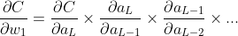
This involves multiplying many derivatives together.
If these derivatives are:
• Less than 1 → multiplication shrinks
• Greater than 1 → multiplication grows
This repeated multiplication causes instability.

📉 1️⃣ Vanishing Gradient Problem

📌 Definition:
The vanishing gradient problem occurs when gradients become extremely small as they propagate backward through deep networks.

🔍 Why It Happens?
Common activation functions like:
• Sigmoid
• Tanh
Have derivatives between:
0 and 1
When multiplied repeatedly across many layers:
Gradient → approaches zero

📊 Effect on Training
• Early layers learn very slowly
• Weights stop updating
• Network fails to learn deep features
• Training becomes ineffective

📌 Example:
If derivative ≈ 0.5
For 10 layers:
Gradient almost becomes zero.

📈 2️⃣ Exploding Gradient Problem

📌 Definition:
The exploding gradient problem occurs when gradients grow exponentially during backpropagation.

🔍 Why It Happens?
If derivatives are:
Greater than 1
Repeated multiplication causes:
Gradient → very large value

📊 Effect on Training
• Weights become extremely large
• Cost function oscillates
• Training becomes unstable
• Model fails to converge

📌 Example:
If derivative ≈ 2
For 10 layers:
Gradient becomes huge.

📊 Diagram Required Here
Diagram Purpose: Gradient flow in deep network
Graphviz DOT Code:
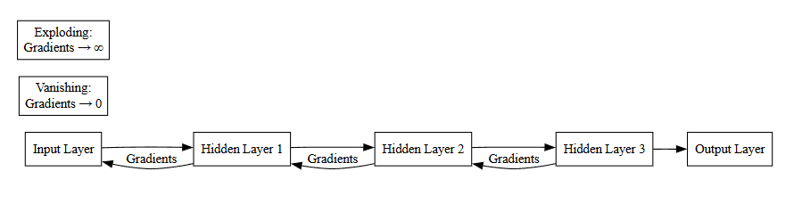

🔬 Why This Was a Major Problem Historically
Earlier deep networks:
• Used sigmoid activation
• Poor weight initialization
• No normalization techniques
Result:
Deep networks could not train properly.
This led to:
AI winter phases.

🛠 Solutions to Vanishing & Exploding Gradients

1️⃣ Use ReLU Activation
ReLU derivative:
• 1 for positive inputs
Prevents gradient shrinkage.

2️⃣ Proper Weight Initialization
Techniques:
• Xavier Initialization
• He Initialization
Keep gradients stable.

3️⃣ Gradient Clipping
Used for exploding gradients.
Limits gradient magnitude:

4️⃣ Batch Normalization
Normalizes activations between layers.
Improves gradient flow.

5️⃣ Residual Networks (ResNet)
Skip connections help gradient flow directly.

📈 Comparison Table
Problem | Cause | Effect | Solution
Vanishing | Derivatives < 1 | Slow learning | ReLU, Initialization
Exploding | Derivatives > 1 | Instability | Gradient clipping

✅ Conclusion (Exam Perfect)
The vanishing and exploding gradient problems arise in deep neural networks due to repeated multiplication of gradients during backpropagation. When gradients shrink exponentially, learning in early layers slows down, resulting in the vanishing gradient problem. When gradients grow excessively, training becomes unstable, leading to the exploding gradient problem. Modern techniques such as ReLU activation, proper weight initialization, batch normalization, gradient clipping, and residual connections help overcome these issues and enable successful training of deep networks.

🎯 Key Points for Exam
• Caused by chain rule multiplication
• Vanishing → gradients approach zero
• Exploding → gradients become large
• Affects deep networks
• ReLU and initialization help solve

Optimization Algorithms in Deep Learning
(SGD, AdaGrad, RMSProp, Adam)

✅ Introduction
Training a neural network involves minimizing the cost function using gradients computed via backpropagation.
Basic Gradient Descent works, but it has problems:
• Slow convergence
• Sensitive to learning rate
• Oscillations
• Poor performance on complex surfaces
To overcome these issues, advanced optimization algorithms were developed.

📌 Definition:
Optimization algorithms are methods used to update neural network parameters efficiently in order to minimize the cost function during training.
They improve:
✔ Convergence speed
✔ Stability
✔ Performance

1️⃣ Stochastic Gradient Descent (SGD)

📌 Concept
Instead of using the entire dataset (Batch GD), SGD updates weights using:
👉 One training sample at a time

Mathematical Update Rule
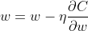
Where:
- = learning rate

Advantages
✔ Faster updates
✔ Less memory
✔ Can escape local minima

Disadvantages
❌ Noisy updates
❌ Oscillates around minimum
❌ May not converge smoothly

Improvement: SGD with Momentum
Momentum adds previous update to current update:
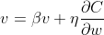
This reduces oscillation.

2️⃣ AdaGrad (Adaptive Gradient)

📌 Concept
AdaGrad adapts learning rate for each parameter individually.
Parameters that receive:
• Large gradients → learning rate decreases
• Small gradients → learning rate increases

Update Rule
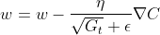

Advantages
✔ Good for sparse data
✔ Automatically adjusts learning rate

Disadvantages
❌ Learning rate becomes very small over time
❌ Training may stop early

3️⃣ RMSProp (Root Mean Square Propagation)

📌 Concept
RMSProp improves AdaGrad by:
👉 Preventing learning rate from shrinking too much.
Instead of accumulating all past gradients, it keeps a moving average.

Update Rule
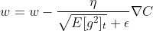

Advantages
✔ Faster convergence
✔ Works well for deep networks
✔ Stable training

Disadvantages
❌ Still sensitive to hyperparameters

4️⃣ Adam (Adaptive Moment Estimation)

📌 Concept
Adam combines:
✔ Momentum
✔ RMSProp
It uses:
• First moment (mean of gradients)
• Second moment (variance of gradients)

Update Equations
First moment:
Second moment:
Bias correction:
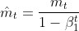
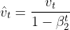
Final update:
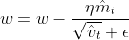

Advantages
✔ Very fast convergence
✔ Works well in most cases
✔ Less tuning required
✔ Default optimizer in many applications

Disadvantages
❌ Slightly more memory usage
❌ Can sometimes overfit

📊 Diagram Required Here
Diagram Purpose: Evolution of optimization algorithms
Graphviz DOT Code:
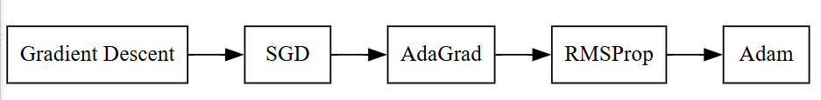

📈 Comparison Table
Optimizer | Learning Rate | Speed | Stability | Usage
SGD | Fixed | Moderate | Noisy | Simple problems
AdaGrad | Adaptive | Slow later | Stable | Sparse data
RMSProp | Adaptive | Fast | Stable | Deep networks
Adam | Adaptive + Momentum | Very Fast | Very Stable | Most popular

🧠 Which Optimizer is Best?
There is no universal best.
But:
👉 Adam is most commonly used
👉 SGD with momentum works well for vision tasks
👉 RMSProp works well for RNNs

✅ Conclusion (Exam Perfect Ending)
Optimization algorithms play a crucial role in training deep neural networks by efficiently minimizing the cost function. While basic gradient descent provides the foundation, advanced algorithms such as SGD, AdaGrad, RMSProp, and Adam improve convergence speed and stability. SGD performs frequent updates, AdaGrad adapts learning rates per parameter, RMSProp prevents excessive decay of learning rates, and Adam combines momentum with adaptive learning for superior performance. Among these, Adam is widely used due to its fast and stable convergence.

🎯 Key Points for Exam
• Optimization minimizes cost function
• SGD updates per sample
• AdaGrad adapts learning rate
• RMSProp improves AdaGrad
• Adam combines momentum + RMSProp
• Adam most popular

Different Optimization Algorithms in Deep Learning
📌 PYQ: Q4 (c) – Mention different optimization algorithms in deep learning

✅ Introduction
In deep learning, optimization algorithms are used to minimize the cost function by updating network weights efficiently using gradients obtained from backpropagation.
Basic gradient descent is slow and unstable for large networks.
Therefore, advanced optimization algorithms are used to improve:
• Convergence speed
• Stability
• Learning efficiency
Some commonly used optimization algorithms in deep learning are explained below.

1️⃣ Stochastic Gradient Descent (SGD)

📌 Concept:
SGD updates weights using one training sample at a time instead of the full dataset.

Mathematical update:


✅ Advantages:
• Faster updates
• Requires less memory
• Can escape local minima

❌ Disadvantages:
• Noisy learning
• Oscillations near minimum

2️⃣ AdaGrad (Adaptive Gradient Algorithm)

📌 Concept:
AdaGrad adjusts the learning rate individually for each parameter based on past gradients.
Parameters with frequent updates get smaller learning rates.

✅ Advantages:
• Works well for sparse data
• Automatically adapts learning rate

❌ Disadvantages:
• Learning rate decreases continuously
• Training may slow down too early

3️⃣ RMSProp (Root Mean Square Propagation)

📌 Concept:
RMSProp improves AdaGrad by using a moving average of squared gradients instead of accumulating all past values.

✅ Advantages:
• Prevents learning rate from becoming too small
• Faster convergence
• Stable training

❌ Disadvantages:
• Sensitive to hyperparameters

4️⃣ Adam (Adaptive Moment Estimation)

📌 Concept:
Adam combines:
✔ Momentum (past gradients)
✔ RMSProp (adaptive learning rate)
It maintains:
• First moment (mean)
• Second moment (variance)

✅ Advantages:
• Very fast convergence
• Works well for deep networks
• Requires little tuning
• Most widely used optimizer

❌ Disadvantages:
• Slightly higher memory usage

📈 Quick Comparison (Good for exam)
Optimizer | Key Feature | Performance
SGD | Simple updates | Moderate
AdaGrad | Adaptive learning rate | Good initially
RMSProp | Stable adaptive learning | Better
Adam | Adaptive + momentum | Best overall

✅ Conclusion (Write this)
Optimization algorithms are essential for efficiently training deep neural networks by minimizing the cost function. While stochastic gradient descent provides the basic approach, advanced methods such as AdaGrad, RMSProp, and Adam improve learning speed and stability by adapting learning rates and utilizing gradient history. Among these, Adam is most commonly used due to its fast and reliable convergence.

🎯 Key Points to Remember
• Used to minimize loss function
• Improve convergence speed
• SGD is simplest
• AdaGrad adapts learning rate
• RMSProp stabilizes AdaGrad
• Adam is most powerful

UNIT I – FOUNDATIONS OF DEEP LEARNING
⚡ Quick Revision Sheet (Exam Focused)

1️⃣ Machine Learning vs Deep Learning
Machine Learning
• Learns from data using algorithms
• Requires manual feature extraction
• Works well for small/medium data
Deep Learning
• Uses multi-layer neural networks
• Learns features automatically
• Works best with large unstructured data
👉 DL is a subset of ML

2️⃣ History of Deep Learning (Timeline Logic)
• 1943 – Artificial neuron model
• 1957 – Perceptron
• 1970s – AI winter (limitations)
• 1986 – Backpropagation
• 2006 – Deep networks revived
• 2012 – Deep learning revolution (big data + GPUs)
👉 Success due to data + computation + better algorithms

3️⃣ Advantages of Deep Learning
✔ Automatic feature extraction
✔ High accuracy
✔ Works on images, audio, text
✔ Handles big data
✔ End-to-end learning

⚠ Challenges
❌ Needs huge data
❌ High computational cost
❌ Black box nature
❌ Overfitting risk
❌ Hard hyperparameter tuning

4️⃣ Learning Representations from Data
• Deep networks learn features layer by layer
• Raw data → simple patterns → complex patterns
• No manual feature engineering
• Called hierarchical feature learning
👉 Core reason for deep learning success

5️⃣ Working of Deep Learning (Layers)
Input Layer:
• Receives raw data
Hidden Layers:
• Perform weighted computation
• Apply activation functions
• Learn features
Output Layer:
• Gives final prediction
Formula:
z = wx + b
a = f(z)

6️⃣ Common Architectural Principles
• Layered hierarchy
• Parameter sharing
• Local connectivity
• Non-linearity (ReLU, sigmoid)
• Depth for abstraction
• Regularization
• Modular design
👉 These make deep networks efficient and stable

7️⃣ Applications of Deep Learning
• Computer vision
• Speech recognition
• NLP
• Healthcare
• Recommendation systems
• Autonomous vehicles
• Fraud detection

8️⃣ Hyperparameters
User-defined training controls
Main ones:
• Learning rate – step size
• Regularization – prevents overfitting
• Momentum – speeds convergence
• Sparsity – fewer active neurons
• Hidden units – network size
👉 Proper tuning = good performance

9️⃣ Cost Function
Measures prediction error
Purpose:
• Guides learning
• Used in backpropagation
• Must be minimized
Common:
• MSE (regression)
• Cross-entropy (classification)

🔁 Training Flow:
Prediction → Cost → Gradient → Weight update

🔟 Backpropagation Algorithm
• Forward pass → compute output
• Compute loss
• Backward pass → compute gradients
• Update weights
Uses:
✔ Chain rule
✔ Gradient descent
👉 Core training algorithm

1️⃣1️⃣ Gradient-Based Learning
• Uses gradients to minimize cost
• Main method: Gradient Descent
Update rule:
w = w − η × gradient
Types:
• Batch
• SGD
• Mini-batch

1️⃣2️⃣ Vanishing & Exploding Gradients
Vanishing:
• Gradients → very small
• Early layers stop learning
Exploding:
• Gradients → very large
• Training unstable
Solutions:
• ReLU
• Good initialization
• Batch normalization
• Gradient clipping

1️⃣3️⃣ Optimization Algorithms
SGD:
Fast but noisy
AdaGrad:
Adaptive learning rate (shrinks over time)
RMSProp:
Fixes AdaGrad shrinking problem
Adam:
Momentum + RMSProp (best overall)
👉 Adam is most used

🎯 SUPER EXAM MEMORY HOOK
DL works because:
Representation Learning
- Backpropagation
- Gradient Descent
- Smart Optimization
- Big Data

Unit II Deep Neural Networks (DNNs)
Biological Neuron vs Artificial Neuron
📌 PYQ: Q3 (a) – Differentiate between biological and artificial neuron

✅ Introduction
The human brain is made up of billions of neurons that process and transmit information through electrical and chemical signals.
Inspired by this natural system, artificial neural networks use artificial neurons to mimic the basic functioning of biological neurons in machines.
Understanding the difference between biological and artificial neurons helps in understanding how deep learning models are designed.

🧠 Biological Neuron

📌 Definition
A biological neuron is a nerve cell in the human nervous system that receives, processes, and transmits information through electrical impulses.

🧩 Main Parts
- 1. Dendrites – receive signals from other neurons
- 2. Cell body (Soma) – processes signals
- 3. Axon – transmits output signal
- 4. Synapse – connection point between neurons

🔁 Working
• Dendrites receive signals
• Cell body sums inputs
• If signal exceeds threshold → neuron fires
• Output passes through axon to other neurons

🤖 Artificial Neuron

📌 Definition
An artificial neuron is a mathematical model inspired by biological neurons used in neural networks to process input data and generate output.

🧩 Main Components
- 1. Inputs (x₁, x₂, …, xₙ)
- 2. Weights (w₁, w₂, …, wₙ)
- 3. Bias (b)
- 4. Summation unit
- 5. Activation function

🔁 Working
• Multiply inputs by weights
• Add bias
• Apply activation function
• Produce output
Mathematically:
z = w₁x₁ + w₂x₂ + ... + wₙxₙ + b
a = f(z)

📊 Diagram Required Here
Diagram Purpose: Structure of biological and artificial neuron
Graphviz DOT Code:
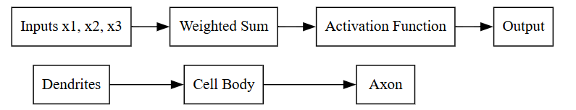

📈 Key Differences (Write in table form)
Feature | Biological Neuron | Artificial Neuron
Nature | Biological cell | Mathematical model
Input | Dendrites | Numerical inputs
Processing | Electrochemical | Weighted sum
Output | Nerve impulse | Numerical value
Learning | Through brain adaptation | Through weight updates
Speed | Slow | Very fast
Accuracy | High adaptability | Depends on training

✅ Conclusion (Perfect exam ending)
Biological neurons are natural information processing units of the human nervous system that communicate through electrical and chemical signals, whereas artificial neurons are simplified mathematical models designed to imitate this behavior in machines. While biological neurons are highly complex and adaptive, artificial neurons operate using weighted computations and activation functions. Together, artificial neurons form neural networks that enable deep learning systems to perform intelligent tasks.

🎯 Key Points to Remember
• Biological neurons are natural
• Artificial neurons are mathematical
• Both receive, process, and transmit signals
• Artificial neuron uses weights and activation
• Inspired from brain structure

📘 Perceptron (AND, OR, NOT, XOR)

✅ Introduction
A Perceptron is the simplest form of an artificial neural network and is considered the building block of deep learning.
It is a single-layer, binary classifier that decides whether an input belongs to one class or another based on a weighted sum and a threshold.
The perceptron was proposed by Frank Rosenblatt and is inspired by the biological neuron.

📌 Definition of Perceptron
A perceptron is a computational model that takes multiple binary inputs, applies weights, adds a bias, and produces a single binary output using an activation function.

🧠 Mathematical Model of Perceptron
For inputs ,,,:
Output:
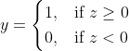
,
Where:
- = weights
- = bias
- Activation = Step (threshold) function

📊 Diagram Required Here
Diagram Purpose: Basic Perceptron Model
Graphviz DOT Code:
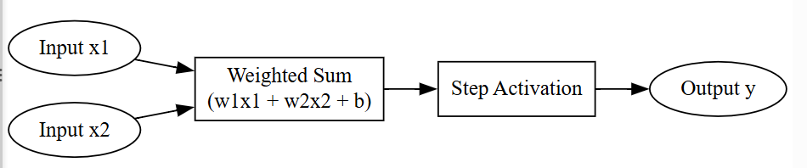

🔹 Perceptron as Logic Gates
Perceptron can implement linearly separable logic gates such as AND, OR, and NOT.

1️⃣ AND Gate using Perceptron
🔹 Truth Table
x₁ | x₂ | AND
0 | 0 | 0
0 | 1 | 0
1 | 0 | 0
1 | 1 | 1

🔹 Weight and Bias Selection
Let:

🔹 Calculation
x₁ | x₂ | z = x₁ + x₂ − 1.5 | Output
0 | 0 | -1.5 | 0
0 | 1 | -0.5 | 0
1 | 0 | -0.5 | 0
1 | 1 | 0.5 | 1
✔ Correct AND behavior

2️⃣ OR Gate using Perceptron
🔹 Truth Table
x₁ | x₂ | OR
0 | 0 | 0
0 | 1 | 1
1 | 0 | 1
1 | 1 | 1

🔹 Weight and Bias Selection
Let:

🔹 Calculation
x₁ | x₂ | z = x₁ + x₂ − 0.5 | Output
0 | 0 | -0.5 | 0
0 | 1 | 0.5 | 1
1 | 0 | 0.5 | 1
1 | 1 | 1.5 | 1
✔ Correct OR behavior

3️⃣ NOT Gate using Perceptron
🔹 Truth Table
x | NOT
0 | 1
1 | 0

🔹 Weight and Bias Selection
Let:

🔹 Calculation
x | z = -x + 0.5 | Output
0 | 0.5 | 1
1 | -0.5 | 0
✔ Correct NOT behavior

❌ XOR Gate using Perceptron (Very Important)

🔹 XOR Truth Table
x₁ | x₂ | XOR
0 | 0 | 0
0 | 1 | 1
1 | 0 | 1
1 | 1 | 0

❓ Why Perceptron Cannot Solve XOR
A single-layer perceptron can only solve linearly separable problems.
XOR is not linearly separable.
Meaning:
❌ No single straight line can separate outputs 0 and 1 correctly.

📌 Geometric Explanation
- AND / OR → separable by one line
- XOR → requires two boundaries
Hence:
👉 Single-layer perceptron fails for XOR

📊 Diagram Required Here
Diagram Purpose: XOR non-linear separability
Graphviz DOT Code:
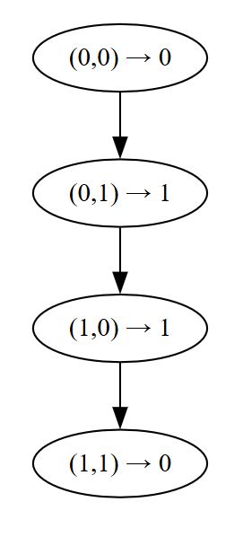

🔑 How XOR is Solved?
By using:
✔ Multi-layer perceptron (MLP)
✔ Hidden layer
✔ Non-linear activation
This discovery led to the rise of deep learning.

📈 Summary Table (Exam Gold)
Gate | Solvable by Perceptron?
AND | Yes
OR | Yes
NOT | Yes
XOR | ❌ No

✅ Conclusion (Perfect Exam Ending)
The perceptron is a fundamental single-layer neural network capable of implementing linearly separable logic functions such as AND, OR, and NOT by appropriate selection of weights and bias. However, it fails to implement the XOR function because XOR is not linearly separable. This limitation led to the development of multi-layer neural networks, which form the foundation of modern deep learning.

🎯 Key Points to Remember
• Perceptron = single-layer neural network
• Uses weighted sum + step activation
• AND, OR, NOT are linearly separable
• XOR is not linearly separable
• XOR limitation led to deep learning

Deep Forward Networks (Deep Feed-Forward Neural Networks)

✅ Introduction
A Deep Forward Network is a neural network in which:
• Information flows in one direction only (forward)
• From input layer → hidden layers → output layer
• Without any feedback loops
It is called deep because it contains multiple hidden layers.
This architecture overcomes the limitations of single-layer perceptrons and enables learning of complex non-linear patterns.

📌 Definition
A deep forward network is a multilayer neural network where data passes sequentially from input to output through several hidden layers, performing hierarchical feature learning using weighted connections and activation functions.

🧱 Basic Structure
A deep forward network consists of:
1️⃣ Input Layer
Receives raw data
2️⃣ Multiple Hidden Layers
Perform computations and feature extraction
3️⃣ Output Layer
Produces final prediction
Each layer contains:
• Neurons
• Weights
• Bias
• Activation function

🔁 Information Flow (Forward Only)
There is:
❌ No feedback
❌ No looping
❌ No memory
Only:
👉 Input → Output
This is why it is called feed-forward

📐 Mathematical Working (Layer by Layer)
For any neuron:
Step 1: Weighted sum
z = w₁x₁ + w₂x₂ + … + wₙxₙ + b
Step 2: Activation
a = f(z)
Output of one layer becomes input to next layer.
This continues until output layer produces final result.

📊 Diagram Required Here
Diagram Purpose: Structure of Deep Forward Network
Graphviz DOT Code:

🧠 Why Multiple Hidden Layers Matter
Each layer learns a higher-level representation:
Layer | Learns
Input | Raw data
Hidden 1 | Simple features
Hidden 2 | Patterns
Hidden 3 | Complex concepts
Output | Decision

Example (Image):
Pixels → edges → shapes → objects → label
This is called:
👉 Hierarchical feature learning

🔑 How Deep Forward Networks Learn
They use:
- 1. Forward propagation
- 2. Cost function
- 3. Backpropagation
- 4. Gradient descent
Repeated until error is minimized.

🚀 What Problems They Can Solve
✔ XOR (not possible with single perceptron)
✔ Image classification
✔ Speech recognition
✔ Pattern detection
✔ Prediction problems

📈 Advantages of Deep Forward Networks
✅ Can learn complex non-linear relationships
✅ Automatic feature extraction
✅ High accuracy
✅ Scalable to big data
✅ Foundation of modern deep learning

⚠ Limitations
❌ Computationally expensive
❌ Needs large datasets
❌ Risk of overfitting
❌ Vanishing gradients (if not handled properly)

📌 Difference from Perceptron (Quick Insight)
Perceptron | Deep Forward Network
Single layer | Multiple layers
Linear problems | Non-linear problems
Simple | Powerful
Cannot solve XOR | Can solve XOR

✅ Conclusion (Perfect Exam Ending)
Deep forward networks are multilayer feed-forward neural networks that process data sequentially from input to output through multiple hidden layers. By applying weighted computations and non-linear activation functions, these networks learn hierarchical representations of data and can model complex non-linear relationships. Their ability to overcome the limitations of single-layer perceptrons makes them the foundation of modern deep learning systems.

🎯 Key Points to Remember
• Data flows only forward
• Has multiple hidden layers
• Learns hierarchical features
• Uses backpropagation
• Solves complex problems
• Core deep learning model

Multilayer Feed-Forward Networks (MLFFN)

✅ Introduction
A Multilayer Feed-Forward Network is an artificial neural network that consists of:
• One input layer
• One or more hidden layers
• One output layer
where information flows only in the forward direction, from input to output, without any feedback or loops.
It is an extension of the single-layer perceptron designed to solve non-linear and complex problems.

📌 Definition
A multilayer feed-forward network is a neural network composed of multiple layers of neurons where each layer is fully connected to the next, and learning is achieved through backpropagation to model complex non-linear relationships.

🧱 Architecture of MLFFN
🔹 Input Layer
Receives raw feature values.
🔹 Hidden Layers
Perform:
• Feature extraction
• Pattern learning
• Non-linear transformations
There may be one or many hidden layers.
🔹 Output Layer
Produces:
• Class label
• Probability
• Numerical prediction

📊 Diagram Required Here
Diagram Purpose: Structure of Multilayer Feed-Forward Network
Graphviz DOT Code:
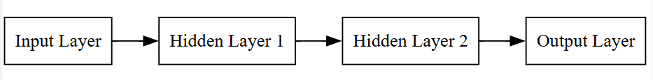

🔁 Forward Computation (Mathematical Flow)
For each neuron in a hidden or output layer:
Step 1: Linear combination
z = Σ(wᵢxᵢ) + b
Step 2: Activation
a = f(z)
Where:
• wᵢ = weights
• xᵢ = inputs
• b = bias
• f = activation function

Output of one layer becomes input to the next.
This continues until final output is produced.

🧠 Why Hidden Layers Are Necessary
Single perceptron:
❌ Learns only linear boundaries
Hidden layers:
✅ Introduce non-linearity
✅ Combine features hierarchically
✅ Solve complex patterns like XOR

Example:
Pixels → edges → shapes → objects → classification

🔄 Learning Process in MLFFN
MLFFN uses:
1️⃣ Forward Propagation
Compute output
2️⃣ Loss Calculation
Measure prediction error
3️⃣ Backpropagation
Compute gradients
4️⃣ Weight Update
Using gradient descent
Repeat until minimum error achieved.

📈 Capabilities of MLFFN
✔ Non-linear classification
✔ Function approximation
✔ Pattern recognition
✔ Prediction tasks
✔ Signal processing

⚙️ Why MLFFN is Powerful
Feature | Benefit
Multiple layers | Deep representation
Non-linear activation | Complex modeling
Backpropagation | Efficient learning
Full connectivity | Strong feature mixing

⚠ Limitations
❌ Computationally heavy
❌ Requires large datasets
❌ Risk of overfitting
❌ Vanishing gradients (if poorly designed)

📌 MLFFN vs Single Perceptron
Aspect | Perceptron | MLFFN
Layers | One | Multiple
Problems solved | Linear | Non-linear
Power | Low | High
XOR | Cannot | Can
Learning | Simple | Advanced

✅ Conclusion (Perfect exam ending)
Multilayer feed-forward networks are advanced neural architectures composed of multiple hidden layers that enable hierarchical feature learning and non-linear modeling. By using weighted connections, activation functions, and backpropagation-based learning, MLFFNs overcome the limitations of single-layer perceptrons and can solve complex real-world problems such as classification, prediction, and pattern recognition. They form the structural foundation of modern deep learning systems.

🎯 Key Points to Remember
• Consists of input, hidden, output layers
• Data flows only forward
• Uses activation functions
• Trained using backpropagation
• Solves complex non-linear problems
• Core of deep learning

Training Neural Networks

✅ Introduction
Training a neural network means adjusting its weights and biases so that:
👉 The predicted output becomes as close as possible to the actual output.
This is achieved using an iterative learning process involving:
- 1. Forward propagation
- 2. Error calculation (loss function)
- 3. Backpropagation
- 4. Weight update using optimization
This cycle continues until the network reaches minimum error.

📌 Definition
Training a neural network is the process of minimizing prediction error by iteratively adjusting model parameters using forward propagation, loss computation, backpropagation, and gradient-based optimization.

🔁 Overall Training Cycle (Big Picture)
Input → Prediction → Error → Gradient → Weight update → Better prediction
Repeated many times (epochs).

📥 1️⃣ Forward Propagation

📌 Purpose
To compute the output of the network using current weights.

Mathematical flow (for each neuron):
z = Σ(wᵢxᵢ) + b
a = f(z)
Where:
• wᵢ = weights
• xᵢ = inputs
• b = bias
• f = activation function

Layer-by-layer:
Input → Hidden layers → Output
Each layer transforms data.

📊 2️⃣ Loss (Error) Computation

After prediction, we measure how wrong the network is.
Loss function compares:
Actual output (y)
Predicted output (ŷ)
Examples:
• Mean Squared Error (regression)
• Cross-Entropy (classification)

Purpose:
Provides learning signal.
Higher loss = worse model
Lower loss = better model

🔄 3️⃣ Backpropagation

📌 Purpose
To determine:
👉 How much each weight contributed to the error.
Uses:
✔ Chain rule of calculus
✔ Gradients

Computes:
∂Loss / ∂Weight for each weight
Starting from output layer moving backward to input.

📉 4️⃣ Weight Update (Optimization)

Weights are updated using gradient descent or its variants:
w_new = w_old − η × gradient
Where:
η = learning rate
This reduces loss gradually.

📊 Diagram Required Here
Diagram Purpose: Neural Network Training Cycle
Graphviz DOT Code:
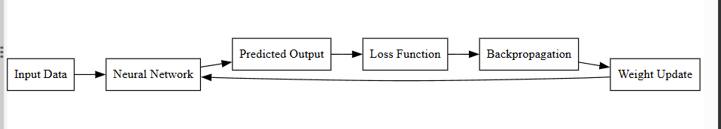

🔁 Complete Training Algorithm (Step-by-Step)
- 1. Initialize weights randomly
- 2. Pass input forward through network
- 3. Compute output
- 4. Calculate loss
- 5. Backpropagate error
- 6. Update weights
- 7. Repeat for many epochs
Until loss becomes minimum.

📈 Why Training Works
Each iteration:
✔ Reduces error slightly
✔ Improves predictions
✔ Learns better features
After many cycles:
Network becomes accurate.

🧠 Important Concepts in Training
🔹 Epoch:
One full pass through dataset
🔹 Batch:
Subset of data
🔹 Learning rate:
Step size for weight updates

⚠ Common Training Problems
• Overfitting
• Slow convergence
• Vanishing gradients
• Poor hyperparameter choice
Solved using:
✔ Regularization
✔ Batch normalization
✔ Good optimizers
✔ Proper architectures

✅ Conclusion (Perfect Exam Ending)
Training a neural network is an iterative optimization process that adjusts model parameters to minimize prediction error. It consists of forward propagation to compute outputs, loss computation to measure error, backpropagation to calculate gradients, and weight updates using gradient-based optimization. Repeating this cycle over multiple epochs enables the network to learn meaningful patterns from data and achieve high accuracy.

🎯 Key Points to Remember
• Training minimizes loss
• Uses forward pass + backward pass
• Backpropagation computes gradients
• Optimizers update weights
• Process repeats iteratively
• Core of deep learning

Forward Propagation (Core Computation in Neural Networks)

✅ Introduction
Forward propagation is the process by which:
👉 Input data is passed through the neural network
👉 Computations are performed at each layer
👉 Final output (prediction) is produced
It is called forward because information flows only from:
Input → Hidden Layers → Output
No backward movement happens in this phase.

📌 Definition
Forward propagation is the step in neural network training where inputs are multiplied by weights, summed with bias, passed through activation functions, and propagated layer by layer to produce the final output.

🧱 Structure Involved in Forward Propagation
Each layer contains neurons that perform:
- 1. Weighted sum
- 2. Bias addition
- 3. Activation transformation

📐 Mathematical Working (Very Important for Exam)
For any neuron:
Step 1 — Linear Combination
Where:
x = input
w = weights
b = bias

Step 2 — Activation Function
Where:
f(z) introduces non-linearity (ReLU, sigmoid, tanh, etc.)

Step 3 — Pass to Next Layer
Output a becomes input for next layer.

This continues until output layer produces final prediction.

🔁 Layer-by-Layer Flow
📥 Input Layer
Receives raw data features.

🧠 Hidden Layers
Each layer:
• Extracts patterns
• Learns representations
• Applies transformations

📤 Output Layer
Produces:
• Class label
• Probability
• Numerical value

📊 Diagram Required Here
Diagram Purpose: Forward propagation flow through neural network
Graphviz DOT Code:
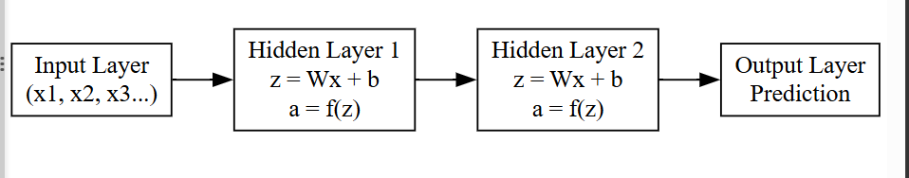

📈 Simple Numerical Example (Concept Clarity)
Suppose:
x₁ = 1, x₂ = 2
w₁ = 0.5, w₂ = 1
b = 1
Step 1:
z = (1×0.5) + (2×1) + 1
z = 0.5 + 2 + 1 = 3.5
Step 2 (ReLU):
a = max(0, 3.5) = 3.5
This output moves to next layer.

🎯 Purpose of Forward Propagation
✔ Generates predictions
✔ Computes values for loss calculation
✔ Prepares gradients for backpropagation
✔ Performs feature transformation
Without forward propagation:
❌ No output
❌ No training
❌ No learning

⚠ Key Observations
• Happens every iteration
• Uses current weights
• Does not change weights
• Only computes outputs

✅ Conclusion (Exam Perfect)
Forward propagation is the fundamental computation process in neural networks where input data is transformed through weighted sums, bias addition, and activation functions across successive layers to produce the final output. It enables hierarchical feature learning and forms the first phase of neural network training before error calculation and backpropagation.

🧾 Key Points to Remember
• Information flows only forward
• Uses weights and bias
• Applies activation functions
• Produces predictions
• Basis for loss computation

Backpropagation Training Algorithm (Error Backpropagation)
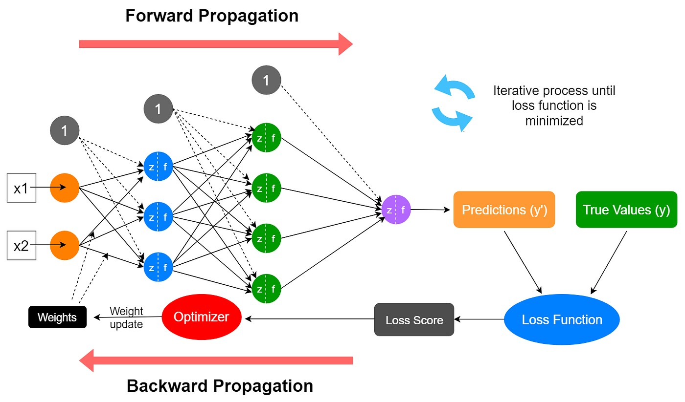
5

✅ Introduction
Backpropagation is the algorithm used to train multilayer neural networks by reducing prediction error.
A neural network initially makes wrong predictions because weights are random.
Backpropagation teaches the network:
👉 how wrong it is
👉 where the mistake happened
👉 how much each weight must change

📌 Definition (Write this in exam)
Backpropagation is a supervised learning algorithm that minimizes the cost function by propagating the error backward through the network and updating weights using gradient descent based on the chain rule of calculus.

🧠 Why Backpropagation is Required
Without backpropagation:
❌ Network cannot learn
❌ Weights remain random
❌ Error never reduces
Backpropagation enables:
✅ Learning from mistakes
✅ Deep networks to work
✅ Continuous improvement

🔄 Two Main Phases of Backpropagation

1️⃣ Forward Propagation (Prediction Phase)
Input passes layer by layer:
For each neuron:
z = Σ(wᵢxᵢ) + b
a = f(z)
Final output is produced.

2️⃣ Error Calculation
Loss function measures difference:
Loss = Actual Output − Predicted Output
Examples:
• Mean Squared Error
• Cross Entropy
This tells how wrong the model is.

3️⃣ Backward Propagation (Correction Phase)
Now the error is sent backward.
Using chain rule, gradients are computed:
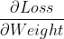
This shows how much each weight caused the error.

4️⃣ Weight Update
Weights are adjusted:
Where:
η = learning rate
This reduces loss gradually.

📐 Mathematical Logic (Simple but Powerful)
Error flows like:
Loss → Output Layer → Hidden Layer → Input Layer
Each layer receives:
“How responsible were you for the error?”
And corrects itself.

🧾 Complete Backpropagation Algorithm (Step-by-step)
- 1. Initialize weights randomly
- 2. Perform forward propagation
- 3. Compute output
- 4. Calculate loss
- 5. Compute gradients at output layer
- 6. Propagate gradients backward
- 7. Update all weights
- 8. Repeat for many epochs
Until loss is minimum.

📈 Why It Works So Well
✔ Efficient gradient computation
✔ Works with many layers
✔ Handles millions of parameters
✔ Enables deep learning revolution

⚠ Problems in Backpropagation
• Vanishing gradients
• Exploding gradients
• Slow convergence
Solved using:
✔ ReLU
✔ Adam optimizer
✔ Batch normalization
✔ Proper initialization

✅ Conclusion (Perfect Exam Ending)
Backpropagation is the fundamental training algorithm of deep neural networks that enables learning by minimizing the cost function through gradient-based optimization. It consists of forward propagation to generate predictions, loss computation to measure error, and backward propagation to compute gradients using the chain rule and update weights. This iterative process allows neural networks to learn complex patterns from data and forms the backbone of modern deep learning systems.

🎯 Key Points to Remember
• Uses forward + backward pass
• Based on chain rule
• Computes gradients
• Updates weights iteratively
• Minimizes error
• Core of deep learning

Activation Functions in Neural Networks

✅ Introduction
In a neural network, after computing the weighted sum:
we apply an activation function to decide:
👉 How much of this signal should pass forward
📌 Definition (Write in exam)
An activation function is a mathematical function that introduces non-linearity into a neural network by transforming the weighted input into an output signal used for further processing.

🎯 Why Activation Functions Are Necessary
Without activation functions:
• Network becomes purely linear
• Multiple layers collapse into one
• Cannot solve complex problems
With activation functions:
✅ Learn curves & patterns
✅ Model real-world data
✅ Enable deep learning

1️⃣ Linear Activation Function
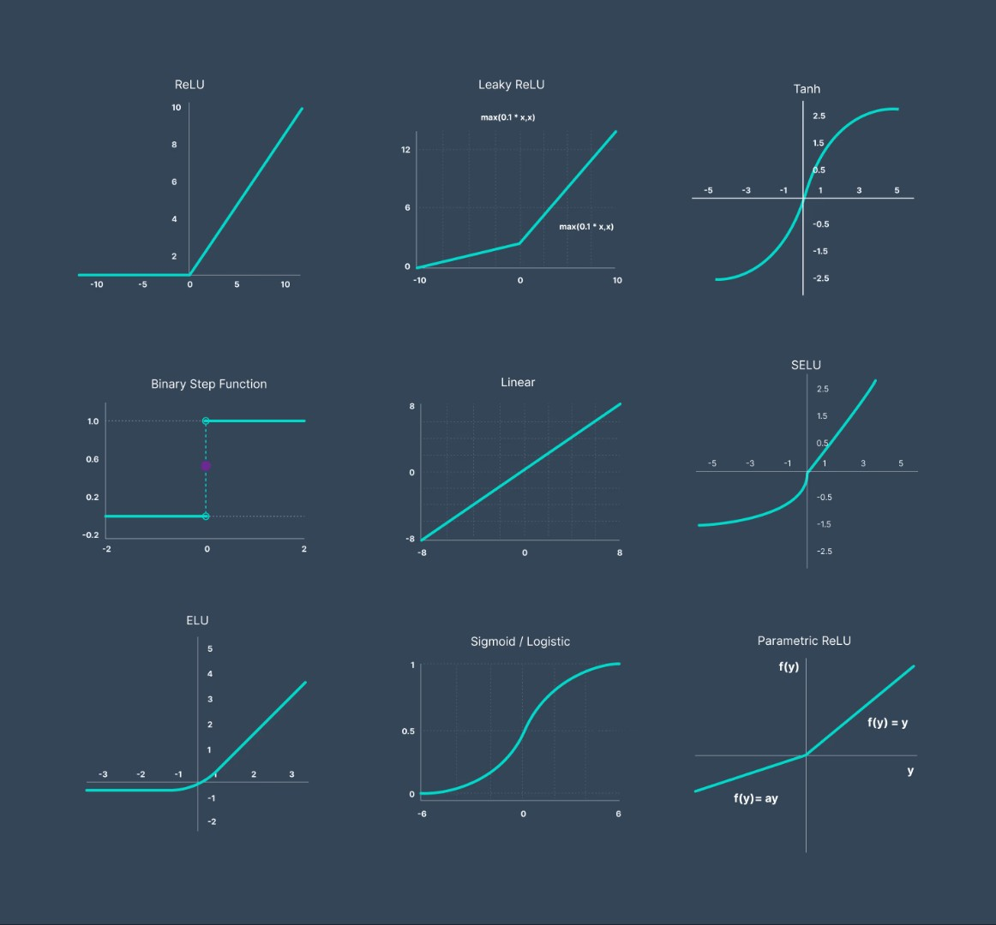
5
📌 Properties
• Output proportional to input
• No non-linearity
❗ Limitation
Using only linear functions makes deep networks useless.
📍 Used in:
Regression output layers

2️⃣ Sigmoid Activation Function
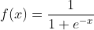
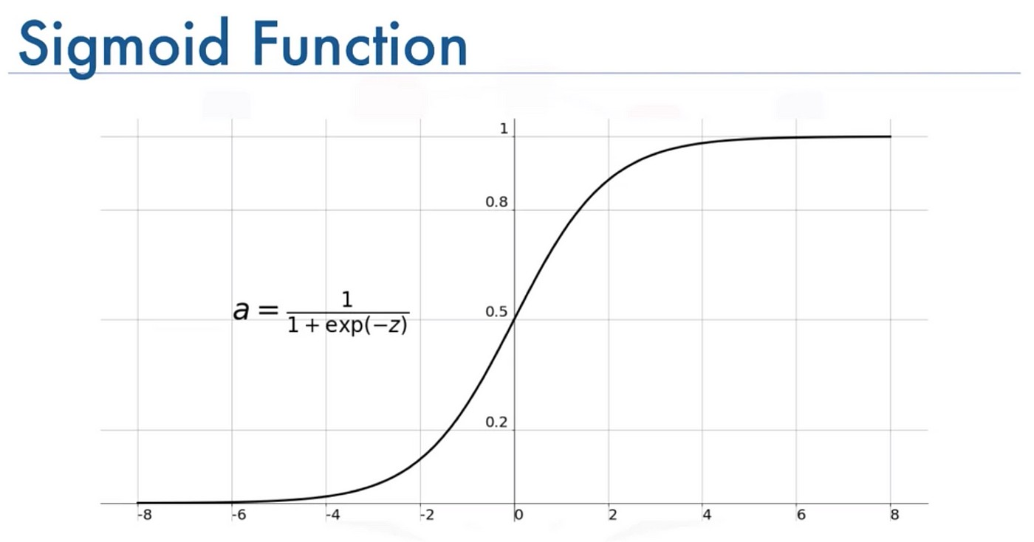
5
📌 Properties
• Output between 0 and 1
• Smooth curve
• Interpretable as probability
❗ Problems
• Vanishing gradient
• Slow learning in deep networks
📍 Used in:
Binary classification output layers

3️⃣ Tanh (Hyperbolic Tangent)
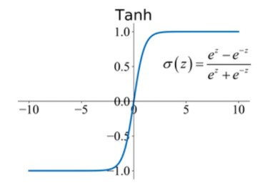
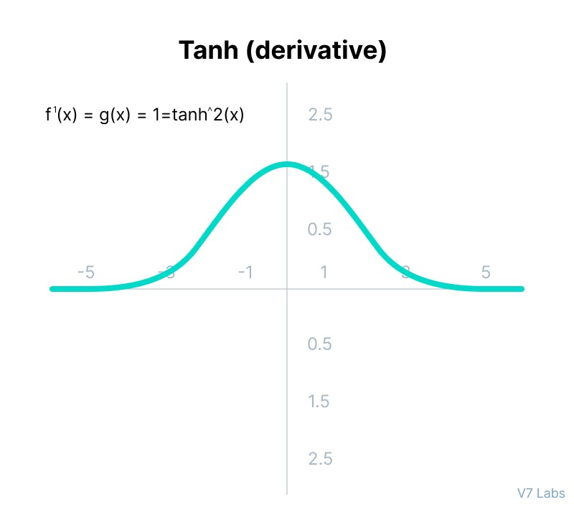
4
📌 Properties
• Output between -1 and 1
• Zero centered (better than sigmoid)
❗ Problems
• Still suffers vanishing gradient
📍 Used in:
Hidden layers (older networks)

4️⃣ ReLU (Rectified Linear Unit)
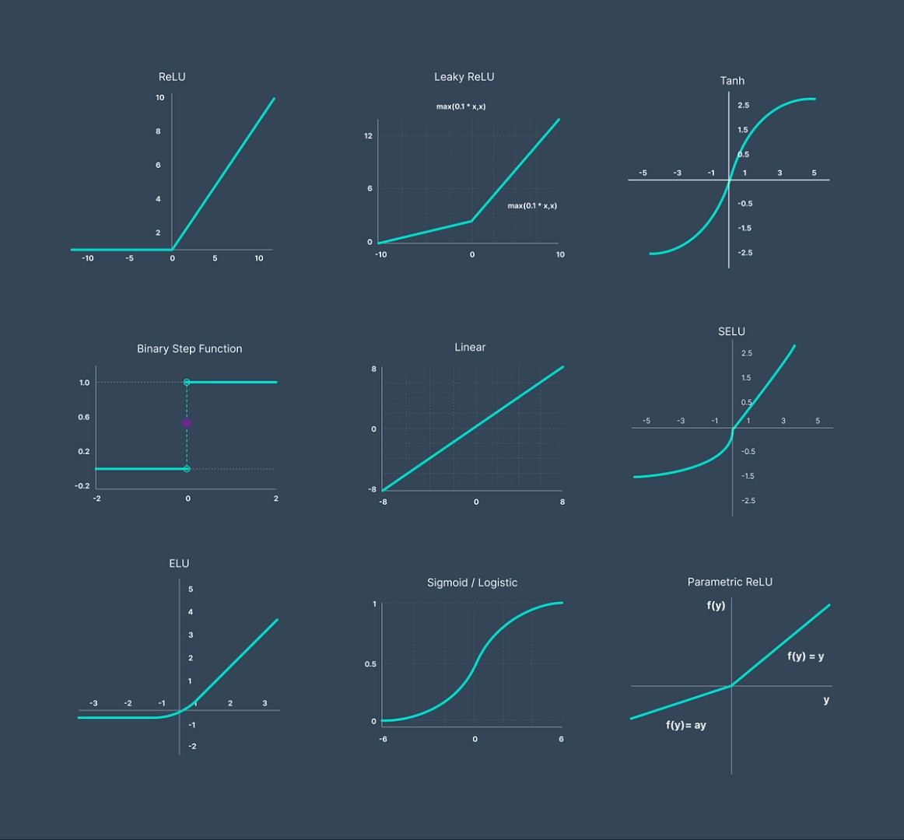
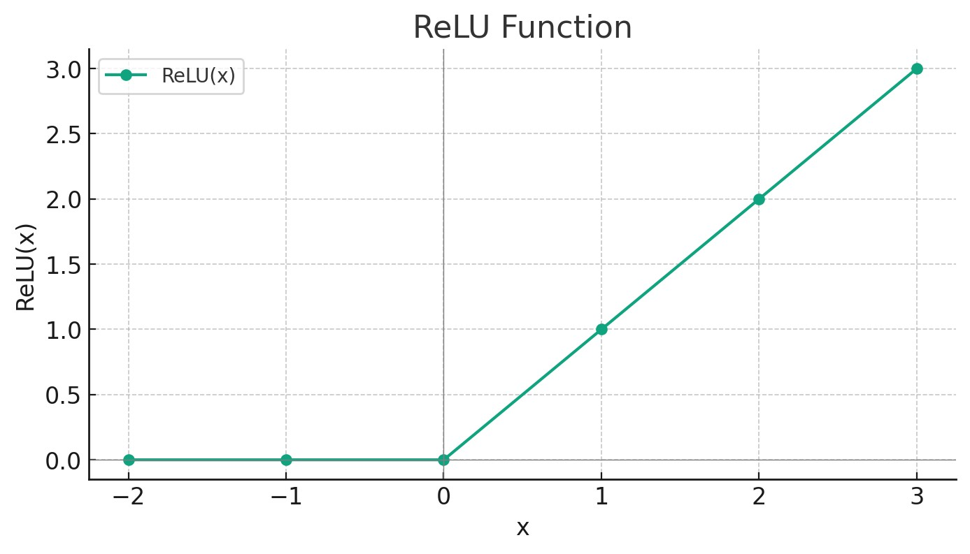
5
📌 Properties
• Zero for negative values
• Linear for positive values
• Very fast computation
✅ Advantages
✔ Solves vanishing gradient largely
✔ Speeds up training
✔ Most used activation today
❗ Problem
• Dying ReLU (neurons stuck at zero)
📍 Used in:
Hidden layers of deep networks

5️⃣ Softmax Activation Function
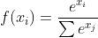
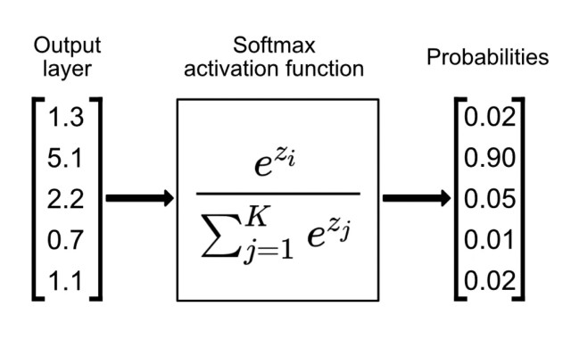
5
📌 Properties
• Converts outputs into probabilities
• Sum of outputs = 1
📍 Used in:
Multi-class classification output layer

📊 Comparison Table (Exam Gold)
Function | Output Range | Main Use | Problem
Linear | (−∞,∞) | Regression | No non-linearity
Sigmoid | (0,1) | Binary output | Vanishing gradient
Tanh | (−1,1) | Hidden layers | Vanishing gradient
ReLU | (0,∞) | Hidden layers | Dying neurons
Softmax | (0,1) | Multi-class output | None major

📈 Choosing Activation Functions (Exam Logic)
• Hidden layers → ReLU
• Binary output → Sigmoid
• Multi-class output → Softmax
• Regression output → Linear

✅ Conclusion (Perfect Exam Ending)
Activation functions introduce non-linearity into neural networks, enabling them to learn complex patterns and relationships. Linear functions are used for regression outputs, sigmoid and tanh for bounded responses, ReLU for efficient deep learning in hidden layers, and softmax for multi-class classification. Proper selection of activation functions is essential for stable training, fast convergence, and high model accuracy.

🎯 Key Points to Remember
• Add non-linearity
• Enable deep learning
• ReLU most popular
• Sigmoid & tanh suffer vanishing gradient
• Softmax for classification

Linear Activation Function

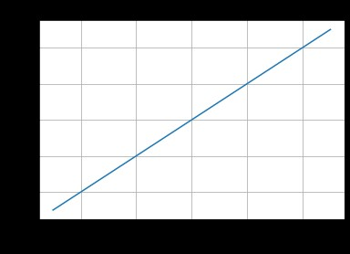
5

✅ Definition
The Linear Activation Function produces an output that is directly proportional to its input.
Mathematically:
(or sometimes , where a is constant)
This means the neuron passes the input value forward without any transformation.

🧠 How It Works in a Neuron
First the neuron computes:
Then applies linear activation:
👉 Output = weighted sum itself
There is no non-linearity added.

📈 Graph Interpretation
• Straight line
• Output increases proportionally with input
• No curve, no bending
This shows the neuron behaves like a simple mathematical equation.

✅ Advantages of Linear Activation
1️⃣ Simple and fast computation
No complex math involved.
2️⃣ Useful for regression problems
When output is continuous like:
• House price
• Temperature
• Sales prediction
3️⃣ Stable output values
No saturation like sigmoid or tanh.

❌ Major Limitation (VERY IMPORTANT FOR EXAM)
🚨 No non-linearity
If all layers use linear activation:
👉 Entire deep network becomes equivalent to a single linear model
Which means:
❌ Cannot learn complex patterns
❌ Cannot solve non-linear problems like XOR
❌ Depth becomes useless

Example:
Even 10 linear layers = one linear equation
So deep learning power is lost.

📌 Where Linear Activation is Used (Selection Logic – Q3c part)
✔ Used in Output Layer for Regression
Example:
Predicting house price:
Output can be:
₹2,50,000
₹5,00,000
₹10,00,000
Linear activation allows any real value.

❌ Not used in hidden layers
Because hidden layers need non-linearity to learn patterns.

🎯 Practical Example (Exam Ready)
Suppose a network predicts temperature:
Input → hidden layers → output
If output neuron uses linear activation:
Predicted value can be:
30°C
45°C
−5°C
Which is correct for real-world measurements.
If sigmoid were used:
Output would be only between 0 and 1 — useless.

📊 Summary Table (Write in exam)
Feature | Linear Activation
Formula | f(x)=x
Output Range | (-∞, +∞)
Shape | Straight line
Non-linearity | ❌ No
Main use | Regression output
Hidden layer use | ❌ No

✅ Conclusion (Perfect Exam Ending)
The linear activation function produces an output directly proportional to the weighted input and does not introduce any non-linearity into the neural network. While it is computationally simple and suitable for regression problems where continuous outputs are required, its major limitation is the inability to model complex relationships. Therefore, linear activation is typically used only in the output layer and not in hidden layers of deep neural networks.

ACTIVATION FUNCTIONS IN DEEP LEARNING (Complete Mastery)

1️⃣ Linear Activation Function

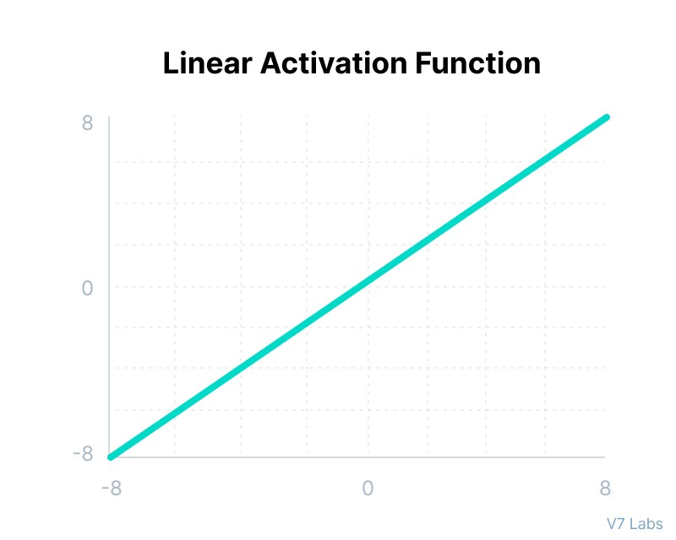
5
📌 Definition
Linear activation passes the input directly as output:
No transformation is applied.

✅ Advantages
✔ Simple and fast
✔ Produces continuous values
✔ Good for regression outputs

❌ Limitations
❌ No non-linearity
❌ Deep networks become useless if used in hidden layers
❌ Cannot model complex patterns

📍 Use
✔ Output layer for regression (price, temperature, demand)

2️⃣ Sigmoid Activation Function

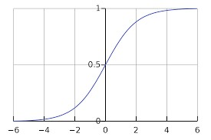
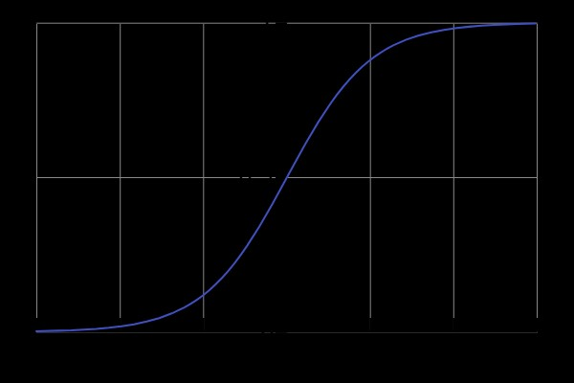
5
📌 Definition

Outputs values between 0 and 1.

✅ Advantages
✔ Smooth and continuous
✔ Interpretable as probability
✔ Useful for binary classification

❌ Limitations
❌ Vanishing gradient problem
❌ Slow training
❌ Not zero-centered

📍 Use
✔ Output layer for yes/no problems (spam detection, disease presence)

3️⃣ Tanh (Hyperbolic Tangent)
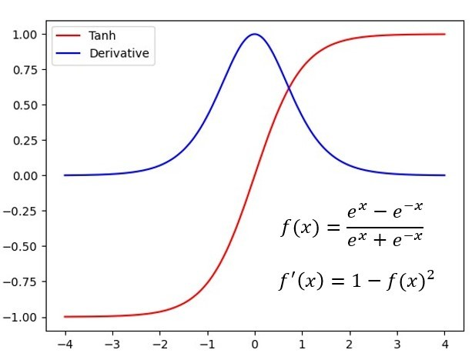

4
📌 Definition
Outputs between -1 and 1.

✅ Advantages
✔ Zero-centered (better than sigmoid)
✔ Stronger gradients near zero
✔ Faster convergence than sigmoid

❌ Limitations
❌ Still suffers vanishing gradient
❌ Saturates at extremes

📍 Use
✔ Hidden layers in older deep networks

4️⃣ Hard Tanh Activation Function

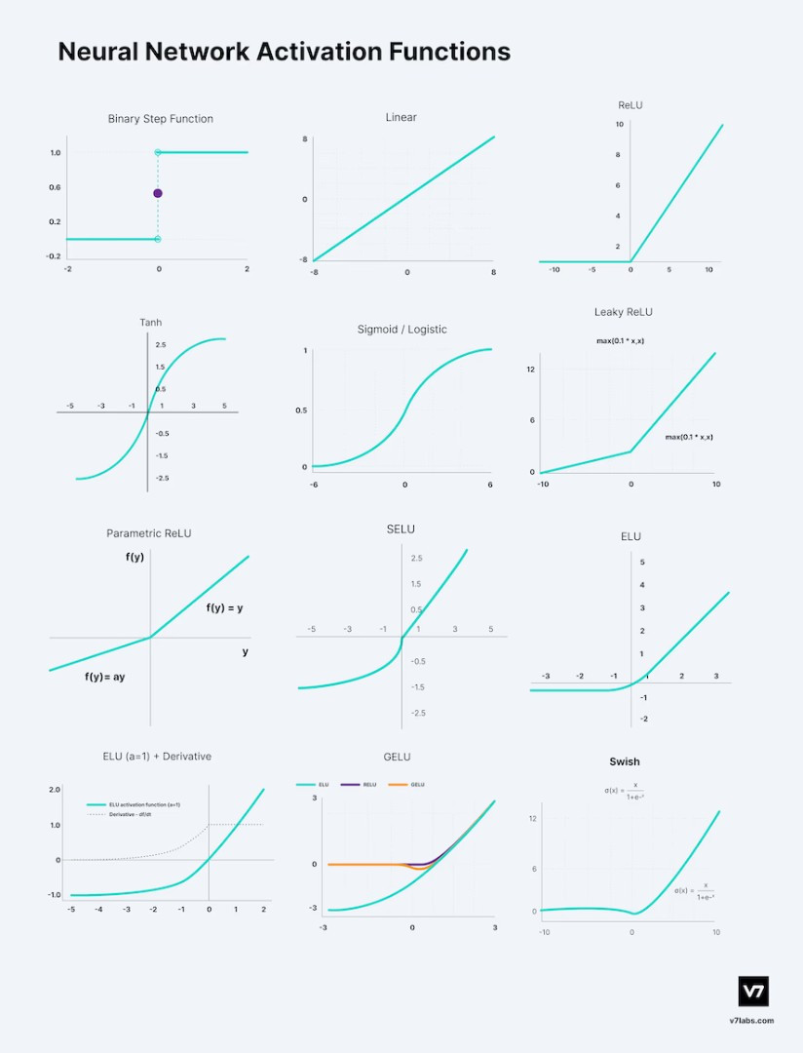
4
📌 Definition
Hard Tanh is a simplified version of tanh:
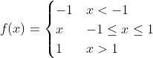

✅ Advantages
✔ Faster computation
✔ Keeps values bounded
✔ Less expensive than tanh

❌ Limitations
❌ Zero gradient outside range
❌ Can stop learning when saturated

📍 Use
✔ Lightweight neural networks
✔ Mobile & embedded systems

5️⃣ ReLU (Rectified Linear Unit)

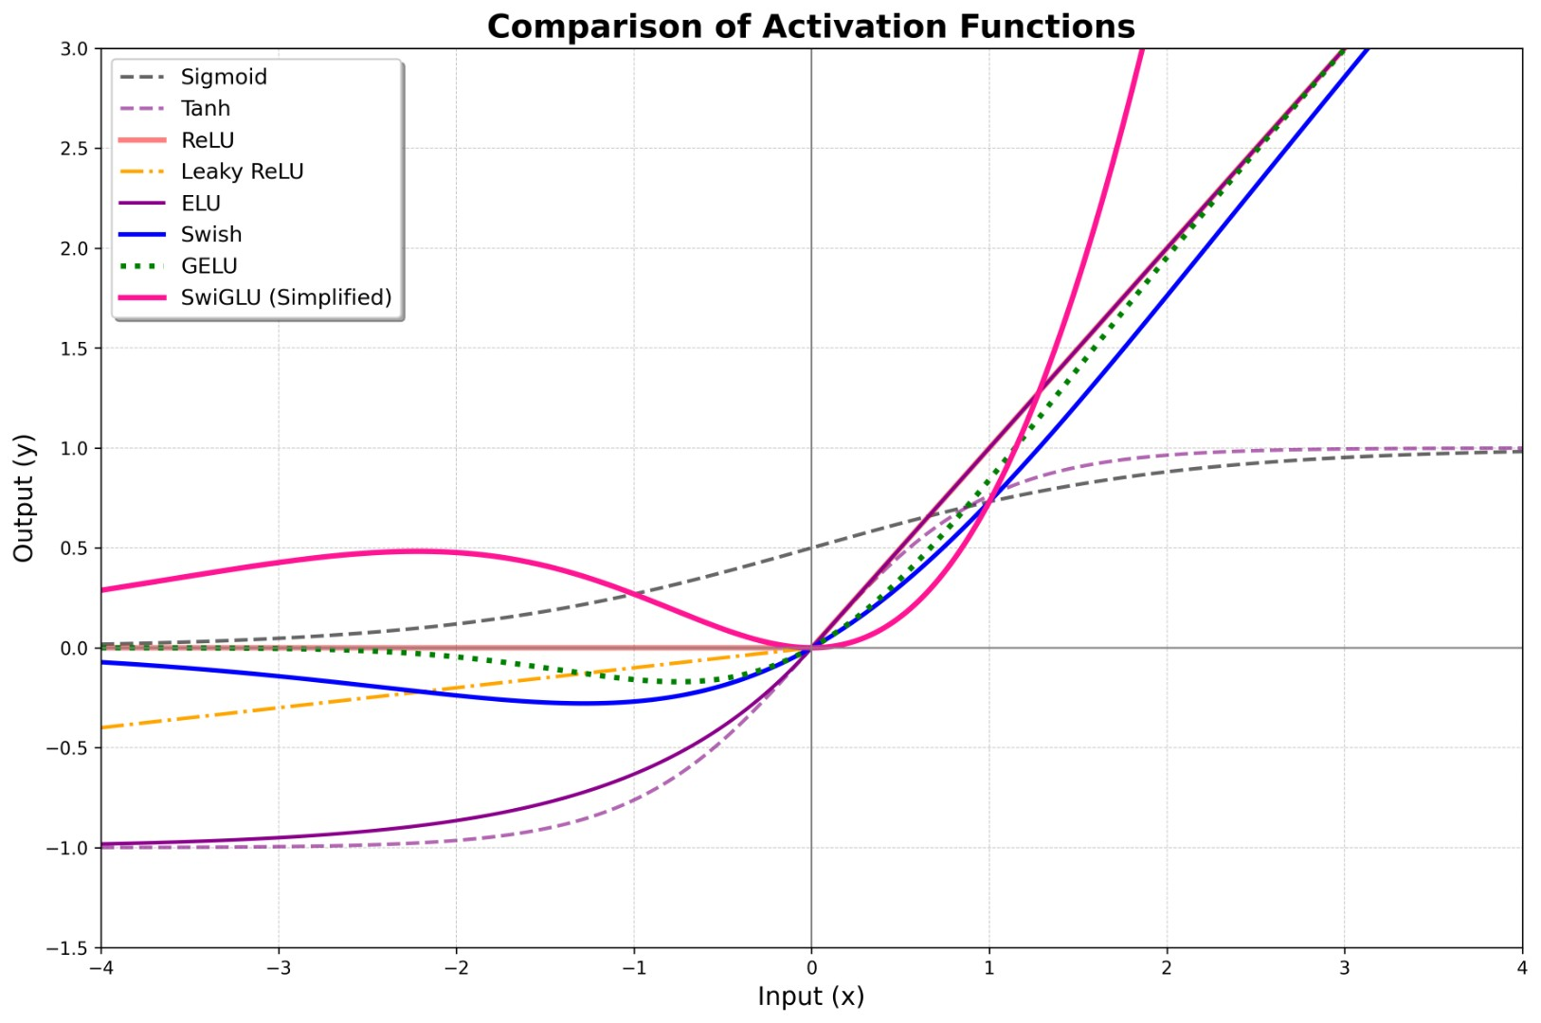
5
📌 Definition
Negative → 0
Positive → unchanged

✅ Advantages
✔ Very fast
✔ Solves vanishing gradient mostly
✔ Enables deep networks to train
✔ Sparse activation

❌ Limitations
❌ Dying ReLU (neurons stuck at zero)
❌ No upper bound

📍 Use
✔ Hidden layers in modern deep networks (MOST COMMON)

6️⃣ Softmax Activation Function

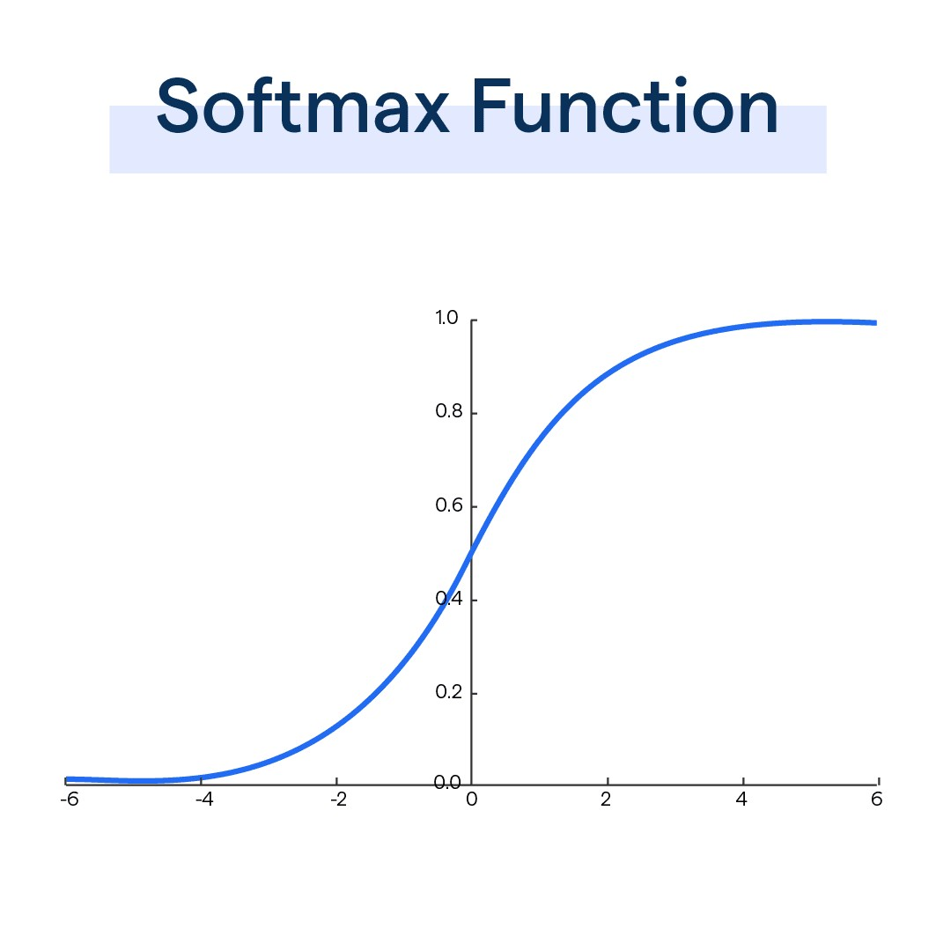
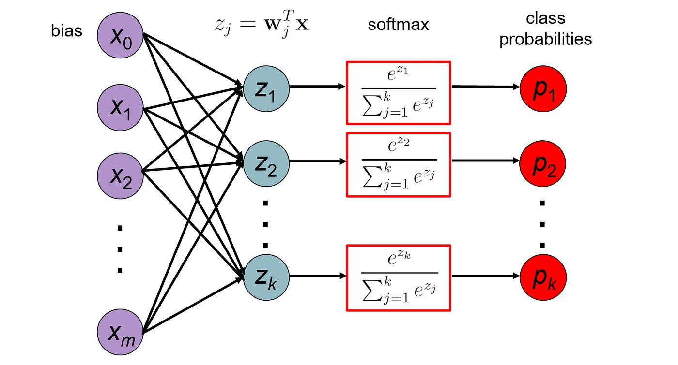
5
📌 Definition

Converts raw scores into probabilities that sum to 1.

✅ Advantages
✔ Produces probability distribution
✔ Clear class decision
✔ Works perfectly with cross-entropy loss

❌ Limitations
❌ Sensitive to large values
❌ Used only in output layer

📍 Use
✔ Multi-class classification (digit recognition, object categories)

📊 Final Comparison (Quick Brain Lock)
Function | Output Range | Main Role | Problem
Linear | (-∞,∞) | Regression output | No non-linearity
Sigmoid | (0,1) | Binary output | Vanishing gradient
Tanh | (-1,1) | Hidden layers | Vanishing gradient
Hard Tanh | [-1,1] | Efficient tanh | Saturation
ReLU | [0,∞) | Hidden layers | Dying neurons
Softmax | (0,1) | Multi-class output | Output only

✅ Final Understanding (Very Important)
Hidden layers → ReLU mostly
Binary output → Sigmoid
Multi-class output → Softmax
Regression output → Linear

How to Select a Particular Activation Function (With Examples)

✅ Introduction
Selecting an activation function is a critical design decision in neural networks because it directly affects:
• Learning speed
• Stability
• Accuracy
• Ability to model complex patterns
There is no single best activation function for all layers.
Instead, the choice depends on:
👉 Type of problem
👉 Location of layer (hidden or output)
👉 Nature of output required

🧠 GENERAL SELECTION RULE (Remember this first)
🔹 Hidden Layers → Need non-linearity → usually ReLU
🔹 Output Layer → depends on task:
Task Type | Activation
Regression (real value) | Linear
Binary classification | Sigmoid
Multi-class classification | Softmax

Now let’s explain each with examples properly 👇

1️⃣ Linear Activation — For Continuous Output Problems

📌 When to Select:
Choose Linear when:
✔ Output is a real number
✔ No upper or lower limit
✔ Prediction value matters directly

📍 Example:
House price prediction:
Output can be:
₹2,50,000
₹5,00,000
₹20,00,000
Using sigmoid or softmax would restrict values.
So:
👉 Linear is selected in output layer

🎯 Reason:
Allows unrestricted continuous values.

2️⃣ Sigmoid Activation — For Binary Decisions

📌 When to Select:
Choose Sigmoid when:
✔ Output has two classes
✔ Result should behave like probability

📍 Example:
Spam detection:
Output:
0 = Not Spam
1 = Spam
Sigmoid gives values between 0 and 1:
0.92 → high chance spam
0.10 → low chance spam

🎯 Reason:
Perfect for yes/no classification.

3️⃣ Tanh Activation — For Hidden Layers (Older Practice)

📌 When to Select:
Choose Tanh when:
✔ Want zero-centered outputs
✔ Working with moderate depth networks

📍 Example:
Signal processing or time-series prediction
Positive and negative values balanced around zero help learning.

🎯 Reason:
Better gradient flow than sigmoid (but still weaker than ReLU).

4️⃣ Hard Tanh — For Fast & Lightweight Models

📌 When to Select:
Choose Hard Tanh when:
✔ Need faster computation
✔ Running on limited hardware (mobile/IoT)

📍 Example:
Embedded systems like sensors or wearable AI.

🎯 Reason:
Simpler version of tanh with less computation.

5️⃣ ReLU — For Hidden Layers in Deep Networks (MOST IMPORTANT)

📌 When to Select:
Choose ReLU when:
✔ Training deep neural networks
✔ Want fast convergence
✔ Want to avoid vanishing gradients

📍 Example:
Image recognition
Speech recognition
Object detection
Almost all modern deep models use ReLU in hidden layers.

🎯 Reason:
Efficient, stable, and powerful.

6️⃣ Softmax — For Multi-Class Classification

📌 When to Select:
Choose Softmax when:
✔ More than two output classes
✔ Need probability distribution

📍 Example:
Digit recognition (0–9)
Output:
Class 0 → 0.05
Class 1 → 0.02
Class 7 → 0.90
Model selects class 7.

🎯 Reason:
Converts outputs into probabilities that sum to 1.

📊 Quick Exam Table (Write This)
Layer Type | Problem | Activation
Hidden | Any deep network | ReLU
Output | Regression | Linear
Output | Binary class | Sigmoid
Output | Multi-class | Softmax
Hidden (older) | Balanced signals | Tanh
Lightweight | Fast models | Hard Tanh

✅ Conclusion (Perfect Exam Ending)
The selection of activation function depends on the role of the layer and the nature of the problem being solved. ReLU is commonly used in hidden layers due to its efficiency and ability to overcome vanishing gradients. Linear activation is chosen for regression outputs, sigmoid for binary classification, and softmax for multi-class classification. Tanh and hard tanh are used in specific cases where zero-centered outputs or computational efficiency is required. Proper selection ensures stable learning and high model performance.

🎯 Key Points to Remember
• Hidden layers → ReLU mostly
• Regression output → Linear
• Binary output → Sigmoid
• Multi-class output → Softmax
• Tanh/Hard Tanh for special cases

UNIT II – Deep Neural Networks (DNNs)
⚡ Quick Revision Sheet

1️⃣ Biological vs Artificial Neuron
🧠 Biological Neuron
• Dendrites → receive signals
• Cell body → processes
• Axon → sends output
• Electrochemical signals
🤖 Artificial Neuron
• Inputs (x₁, x₂…)
• Weights (w₁, w₂…)
• Bias (b)
• Activation function
Formula:
z = Σ(wx) + b
a = f(z)
👉 Artificial neuron is mathematical model of biological neuron.

2️⃣ Perceptron (AND, OR, NOT, XOR)
📌 Perceptron
• Single-layer binary classifier
• Uses step activation
• Solves linearly separable problems
✔ AND, OR, NOT → Solvable
❌ XOR → Not solvable (not linearly separable)
👉 XOR limitation led to multilayer networks.

3️⃣ Deep Forward Networks
• Multiple hidden layers
• Data flows forward only
• Learns hierarchical features
• Solves non-linear problems
Structure:
Input → Hidden layers → Output
👉 Foundation of deep learning.

4️⃣ Multilayer Feed-Forward Networks (MLFFN)
• Extension of perceptron
• Multiple hidden layers
• Uses backpropagation
• Learns complex patterns
Key idea:
Non-linearity + depth = power

5️⃣ Training Neural Networks
Training cycle:
Input → Forward Propagation → Loss → Backpropagation → Weight Update
Repeat for many epochs.
Key components:
• Loss function
• Gradient descent
• Learning rate

6️⃣ Forward Propagation
• Computes prediction
• Uses weighted sum + activation
• Does not update weights
z = Σ(wx) + b
a = f(z)

7️⃣ Activation Functions
Linear
• f(x)=x
• Used for regression output
Sigmoid
• Output (0,1)
• Binary classification
Tanh
• Output (-1,1)
• Zero-centered
Hard Tanh
• Clipped tanh
• Faster computation
ReLU
• f(x)=max(0,x)
• Most used in hidden layers
Softmax
• Converts outputs to probabilities
• Multi-class classification

🎯 Activation Selection Logic
Hidden layers → ReLU
Regression output → Linear
Binary output → Sigmoid
Multi-class output → Softmax

🔥 Core Concepts to Remember
✔ Perceptron fails for XOR
✔ Hidden layers introduce non-linearity
✔ Backpropagation trains network
✔ ReLU solves vanishing gradient largely
✔ Softmax outputs probability distribution

🧠 If You Understand Unit II, You Understand:
• How neurons work
• How networks are built
• How they learn
• How they make decisions

